

WebMinds, Inc.

TM

Version v7.0

User Manual (For Windows Users)

Version

Copyright © WebMinds, Inc., 2024

All Rights Reserved

This publication is protected by federal copyright law. No part of this publication may be copied or distributed, stored in a retrieval system, or translated into any human or computer language in any form or by any means, electronic, mechanical, magnetic, manual or otherwise, or disclosed to third parties without the express written permission of **WebMinds, Inc.**

**WebMinds, Inc.** makes no representation or warranties with respect to the contents hereof and specifically disclaim any implied warranties of merchantability or fitness for a particular purpose. Further, **WebMinds, Inc.** reserves the right to revise this publication and to make changes from time to time in the contents hereof without obligation of **WebMinds, Inc.** to notify any person or organization of such revision or changes.

**WebMinds, Inc.** has prepared this guide for use by **WebMinds, Inc.** personnel and authorized third parties as a guide to proper operation and/or maintenance of **WebMinds, Inc.** equipment and software. The drawings and specifications contained herein are the property of **WebMinds, Inc.**

Trademarked names may appear throughout this user manual. Rather than list the names and entities that own the trademarks or insert a trademark symbol with each mention of the trademarked name, the names are used only for editorial purposes and to the benefit of the trademark owner with no intention of infringing upon that trademark.

Address comments and corrections to:

**WebMinds, Inc.**

950 N Collier Blvd. Suite 400

Marco Island FL 34145

USA

Revision History

|  |  |  |  |
| --- | --- | --- | --- |
| Date | Release | Revision DESCRIPTION | MODIFIED BY |
| Mar 01, 2024 | 0.1 | Initial draft | David A. Flynn |
| Mar 14, 2024 | 1.0 | First base lined user manual | David A. Flynn |
|  |  |  |  |
|  |  |  |  |
|  |  |  |  |
|  |  |  |  |

About this User Manual

This user manual contains information about all the features & functionalities of the Duplicate Photo CleanerTM application & instructions on how to use them.

Purpose of this User Manual

The purpose of this user manual is to assist the end users of the TM application.

In Scope of this User Manual

The scope of this user manual includes the description and usage of the TM application.

Out of Scope of this User Manual

The scope of this user manual does not include –

* the detailed installation process of TM application
* the usage of the features and functionalities of your operating system

Intended Audience of this User Manual

The intended audiences of this user manual are –

* end users of the TM application

Organization of this User Manual

This user manual contains 12 chapters & 1 appendices as indicated below –

| chapter | Description |
| --- | --- |
| **Chapter 1** | Introduction |
| **Chapter 2** | Getting Started |
| **Chapter 3** | Registering your DPC Application Installation |
| **Chapter 4** | Activating your DPC Application Installation |
| **Chapter 5** | Removing your DPC License Details |
| **Chapter 6** | Performing a Standard Scan |
| **Chapter 7** | Performing a Mobile SmartScan |
| **Chapter 8** | Performing a Folder Comparison |
| **Chapter 9** | Performing a Picassa Scan |
| **Chapter 10** | Performing a Lightroom Classic Scan |
| **Chapter 11** | Performing a PaintShop Pro Scan |
| **Chapter 12** | Performing a Fragment Search |
| **Appendix A** | Frequently Asked Questions |

Typographical Conventions / Customaries used in this User Manual

The typographical conventions used in this user manual include the following –

* **Note:** The purpose of this typographical convention is to provide important information corresponding to an already stated fact. This is how we depict a note in this user manual –

**Note:**<Note Text><Note Text><Note Text><Note Text><Note Text><Note Text><Note Text><Note Text><Note Text><Note Text><Note Text><Note Text><Note Text><Note Text>

* **Tip:** The purpose of this typographical convention is to provide additional information supplementing an already stated fact. This is how we depict a tip in this user manual –

**Tip:**<Tip Text><Tip Text><Tip Text><Tip Text><Tip Text><Tip Text><Tip Text><Tip Text><Tip Text><Tip Text><Tip Text><Tip Text><Tip Text><Tip Text><Tip Text><Tip Text><Tip Text>

* **Warning:** The purpose of this typographical convention is to provide critical information corresponding to an already stated fact. This is how we depict a warning in this user manual –

**Warning:**<Warning Text><Warning Text><Warning Text><Warning Text><Warning Text><Warning Text><Warning Text><Warning Text><Warning Text><Warning Text><Warning Text>

* **Reference:** The purpose of this typographical convention is to refer you to another section in this user manual or another document or to an external reference. A reference is depicted in the following manner in this user manual –

**Reference:** To read detailed steps, navigate to **<Chapter Name>** chapter by clicking this link.

or

**Reference:** For more information, navigate to **<Chapter Name>** chapter by clicking this link.

Abbreviations / Acronyms used in this User Manual

The table below describes the abbreviations / acronyms used in this user manual –

|  |  |
| --- | --- |
| Abbreviation | Description |
| **GUI, UI** | Graphical User Interface, User Interface |
| **IPR** | Intellectual Property Rights |
| **DPC** | Duplicate Photo Cleaner |
| **TM** | Trade Mark |
| **TOC, TOT, TOF** | Table of Contents, Table of Tables, Table of Figures |
| **PC** | Personal Computer |
| **FAQs** | Frequently Asked Questions |

Terms Used in this User Manual

The below table briefly describes the terms utilized in this user manual –

| chapter | Description |
| --- | --- |
| **End User** | An operator or user of the Duplicate Photo Cleaner TM application. |

Table of Contents

Revision History ii

About this User Manual iii

Purpose of this User Manual iii

In Scope of this User Manual iii

Out of Scope of this User Manual iii

Intended Audience of this User Manual iii

Organization of this User Manual iii

Typographical Conventions / Customaries used in this User Manual iv

Abbreviations / Acronyms used in this User Manual v

Terms Used in this User Manual v

Table of Contents 6

Table of Figures 8

Chapter - 1. Introduction 10

1.1 Downloading the DPC Application Installer 10

Chapter - 2. Getting Started 11

2.1 The Settings Panel Detailed Description 13

2.1.1 The General tab 13

2.1.2 The Scan Settings tab 15

2.1.3 The Logging tab 17

2.1.4 The Ignore List tab 18

2.1.5 The Sounds tab 19

2.1.6 The Support tab 20

2.2 Limitations of Utilizing an Unregistered DPC Application in Trial Mode 21

Chapter - 3. Registering your DPC Application Installation 22

3.1 Via the DPC Homepage 22

3.2 Via the Register Button of DPC Application 25

Chapter - 4. Activating your DPC Installation 28

Chapter - 5. Removing your DPC License Details 31

Chapter - 6. Performing a Standard Scan 34

Chapter - 7. Performing a Mobile SmartScan 38

Chapter - 8. Performing a Folder Comparison 44

Chapter - 9. Performing a Picassa Scan 48

Chapter - 10. Performing a Lightroom Classic Scan 52

Chapter - 11. Performing a PaintShop Pro Scan 56

Chapter - 12. Performing a Fragment Search 61

Appendix - A. Frequently Asked Questions (FAQs) 65

Index 83

Table of Figures

Figure 1 – Downloading the Duplicate Photo CleanerTM application installer executable file 10

Figure 2 – Duplicate Photo CleanerTM default screen 11

Figure 3 – Duplicate Photo CleanerTM settings panel – the General tab 13

Figure 4 – Duplicate Photo CleanerTM settings panel – the Scan Settings tab 15

Figure 5 – Duplicate Photo CleanerTM settings panel – the Logging tab 17

Figure 6 – Duplicate Photo CleanerTM settings panel – the Ignore List tab 18

Figure 7 – Duplicate Photo CleanerTM settings panel – the Sounds tab 19

Figure 8 – Duplicate Photo CleanerTM settings panel – the Support tab 20

Figure 9 – Registering your DPC application installation via the DPCTM homepage 22

Figure 10 – Specifying your registration details 23

Figure 11 – Secure Registration page 24

Figure 12 – DPC application default page 25

Figure 13 – DPC application license key specification – step 1 25

Figure 14 – DPC application license key specification – step 2 26

Figure 15 – DPC application license key specification – step 3 26

Figure 16 – DPC application license key activation successful 27

Figure 17 – DPC application default screen 28

Figure 18 – Activating DPC application – step 1 29

Figure 19 – Activating DPC application – step 2 29

Figure 20 – DPC application default screen 31

Figure 21 – Removing DPC application license key details – About popup 32

Figure 22 – Removing license key details confirmation popup 32

Figure 23 – Successful Removal of DPC application license key details 33

Figure 24 – Performing offline data migration 34

Figure 25 – Selecting a folder 34

Figure 26 – Exporting you data folders & files 35

Figure 27 – Performing offline data migration 36

Figure 28 – Selecting a folder 36

Figure 29 – Importing your data files & folders 37

Figure 30 – Performing online data migration – PC1 38

Figure 31 – Performing online data migration – PC2 39

Figure 32 – Performing online data migration – PC2 39

Figure 33 – Specifying the IP Adress of your second or newer PC 40

Figure 34 – Specifying the data folders & files to migrate from your first or older PC to your second or newer PC 41

Figure 35 – Importing your data folders & files 41

Figure 36 – Selected data folders & files 42

Figure 37 – Selected data folders & files 42

Figure 38 – Performing online data migration – PC1 44

Figure 39 – Performing online data migration – PC2 45

Figure 40 – Performing online data migration – PC2 45

Figure 41 – Specifying the IP Adress of your second or newer PC 46

Figure 42 – Specifying the users to migrate from your first or older PC to your second or newer PC 46

Figure 43 – Performing online data migration – PC1 48

Figure 44 – Performing online data migration – PC2 49

Figure 45 – Performing online data migration – PC2 49

Figure 46 – Specifying the IP Adress of your second or newer PC 50

Figure 47 – Users screen 51

Figure 48 – Importing your software 51

Figure 49 – Performing online data migration – PC1 52

Figure 50 – Performing online data migration – PC2 53

Figure 51 – Performing online data migration – PC2 53

Figure 52 – Specifying the IP Adress of your second or newer PC 54

Figure 53 – Users screen 55

Figure 54 – Importing your drivers 55

Figure 55 – Performing online data migration – PC1 56

Figure 56 – Performing online data migration – PC2 57

Figure 57 – Performing online data migration – PC2 57

Figure 58 – Specifying the IP Adress of your second or newer PC 58

Figure 59 – User screen 59

Figure 60 – Importing your favorites from your default browser 59

Figure 61 – Performing online data migration – PC1 61

Figure 62 – Performing online data migration – PC2 62

Figure 63 – Performing online data migration – PC2 62

Figure 64 – Specifying the IP Adress of your second or newer PC 63

Figure 65 – User screen 64

Figure 66 – Importing your favorites from your default browser 64

Figure 67: Opening the Search / Filter window 74

Figure 68: Search / Filter window 74

Figure 69: Scan Summary window 75

Figure 70: Scan Results window 75

Figure 71: Pausing a scan 79

# Introduction

With the advent of hand-held digital devices anyone with a decent smartphone with a good camera can capture his / her memories digitally alleviating the need to print each and every photograph. However, each use case scenario has its blessings and limitations. Even though, in the world of today storage space is cheap, it still requires some amount of maintenance and house-keeping activities. This is where Duplicate Photo CleanerTM (DPC) enables you to search for duplicate photos so that you can delete them in one go.

**Reference:** To view our Duplicate Photo CleanerTM promotional video, visit <https://youtu.be/mAUO57Y3QmA>

Downloading the DPC Application Installer

You can download the Duplicate Photo Cleaner TM application from the **Download** link available in the menu on the Duplicate Photo Cleaner TM homepage as depicted in the figure below –

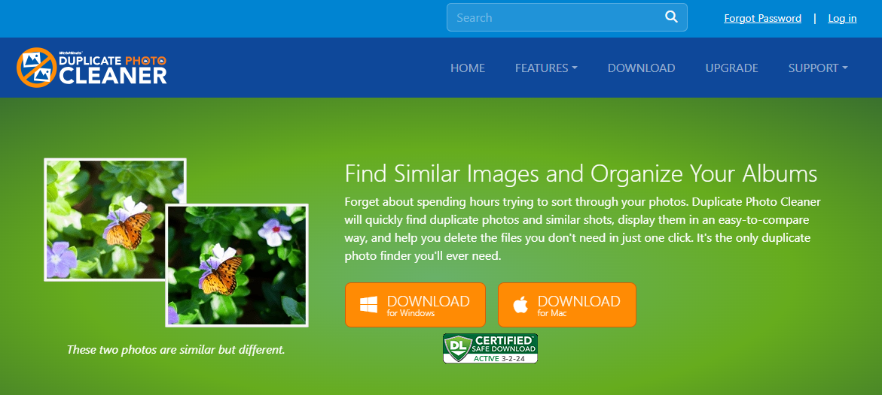

Figure 1 – Downloading the Duplicate Photo CleanerTM application installer executable file

**Tip:** After you click the above-mentioned links, you may be warned by your web-browser about a potential security risk due to the downloaded executable file. Please authorize this file.

You can follow the installation wizard by launching the downloaded Duplicate Photo Cleaner TM installer executable file to install the Duplicate Photo Cleaner TM application on your system.

**Tip:** After you open the downloaded executable file, you may be warned by your operating system before you can install this application on your system. Please authorize your operating system to continue installing this application at this step.

The next chapter gets you started with the Duplicate Photo Cleaner TM application that you just installed.

# Getting Started

Double click on the desktop icon of Duplicate Photo CleanerTM application. Your DPC application will be launched as depicted in the figure below –

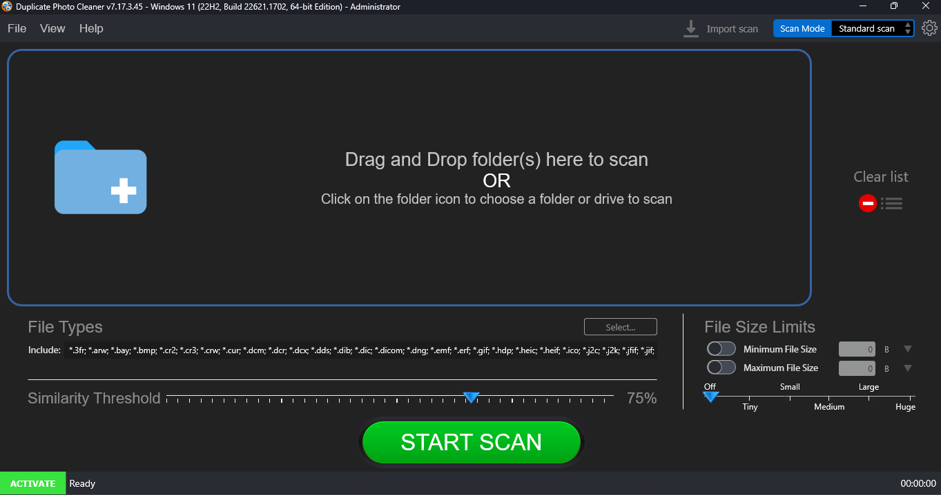

Figure 2 – Duplicate Photo CleanerTM default screen

Below is a description of the screen elements of the default screen of the TM application.

| **NO.** | | **DESCRIPTION** |
| --- | --- | --- |
| **1** | | This is the main toolbar of the DPC application. The main operations that you can perform using the options on the toolbar are as follows –   * **File –** This option enables you to Start a Scan in the standard view as depicted in the figure above. * **Exit –** This option enables you to close from the DPC application. * **View –** This option enables you to change the view of photos as they are displayed on your screen in all of the modes. The common sub-options are – as a Table, Tree, Multiview, or Theatre. * **Help –** This option enables you to perform the following actions –   + **User Guide –** Clicking this option enables you to view this user guide.   + **Update –** Clicking this option enables you to check if any updates of the DPC application are available.   + **About -** Clicking this option enables you to view your license information in case you have registered DPC application installation. This option also enables to and purchase a license key depending on the package of your choice. Also, this sub-option enables you to register you application installation and activate it after the system validates your license key successfully.   **Reference:** To register your DPC application installation, refer to **Registering your DPC Application Installation** chapter by clicking this link.  **Reference:** To activate your DPC application installation, refer to **Activating your DPC Installation** chapter by clicking this link.  **Reference:** To remove your DPC application license details, refer to **Removing your DPC License Details** chapter by clicking this link. |
| **2** | | Clicking this scan type drop-down list enables you to specify the scan type you intend to perform. Chapters 6 to Chapter 12 describe each scan type in detail. |
| **3** | | This section indicates the current state of your DPC installation. In this case where it says **Activate**, indicates that your current DPC installation is not registered and activated.  **Reference:** An unregistered & inactivated DPC installation poses the 10-item clean limitation. To read more about this limitation, refer to the next sub-section.  Clicking the **ACTIVATE** button opens the Registration / Activation popup.  **Reference:** To register your DPC application installation, refer to **Registering your DPC Application Installation** chapter by clicking this link.  **Reference:** To activate your DPC application installation, refer to **Activating your DPC Installation** chapter by clicking this link. |
| **4** | Clicking this button opens the Settings panel.  **Tip:** For a detailed description of the Settings panel, refer to **The Settings Panel Detailed Description** section. | |

The Settings Panel Detailed Description

This sub-section describes all tabs and all the provided parameters on each of these tabs on the Settings panel.

The General tab

The parameters available on the General are applicable on most of the common settings of the DPC application. Below are detailed descriptions of the General tab and its parameters as depicted in the figure below –

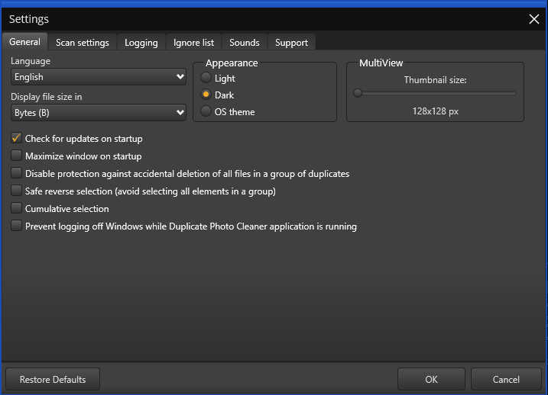

Figure 3 – Duplicate Photo CleanerTM settings panel – the General tab

* **General –** This tab includes all general settings that are application on DPC application.
  + **Language –** This drop-down list enables you to change the language of you DPC application installation.
  + **Display file size in –** This drop-down list enables you to specify the unit of measurement of data that is to be used to display the file size. E.g. In today’s world, most images are measured in mega-bytes or MBs.
  + **Appearance –** These mutually inclusive radio buttons enable you to specify which appearance theme is to be applied – i.e. Light, meaning the Windows grey theme, Dark, meaning a black theme, or OS theme, meaning whatever the Windows theme is being used, that will be applied to DPC.
  + **MultiView –** This slider enables you to specify the size of the thumbnail that is to be utilized while DPC creates a temporary thumbnail of the actual image in all scan types
  + **Check for updates on startup –** This checkbox enables you to specify if DPC has to check for updates when it is starting up
  + **Maximize window on startup –** This checkbox enables you to specify if DPC has to maximize its window when it is starting up
  + **Disable protection against accidental deletion of all files in a group of duplicates –** This checkbox enables you to specify if you want to disable protection against accidental deletion all files in a group of found duplicates
  + **Safe reverse selection (avoid selecting all elements in a group) –** This checkbox enables you to specify if you want to disable protection against safe reverse selection
  + **Cumulative selection –** This checkbox enables you to specify how your file selection action behaves while you move your mouse cursor. Typically, in Windows, we press the Shift key to select all files between the first and the last selection. Selecting this checkbox alleviates the need to press the Shift key but on the other hand it becomes impossible to do specific one-by-one file selection in group of duplicate files
  + **Prevent logging off Windows while Duplicate Photo Cleaner application is running –** This checkbox enables you to specify if DPC will prevent logging off Windows while it is running
* **Restore Defaults –** Clicking this button reverts all settings to the default mode of DPC.
* **OK –** Clicking this button saves the changes made and closes this panel
* **Cancel –** Clicking this button ignores the changes made and closes this panel

The Scan Settings tab

The parameters available on the Scan Settings tab enable you to fine tune the scan algorithm to produce better scan results during image comparisons. Below are detailed descriptions of the Scan Settings tab and its parameters as depicted in the figure below –

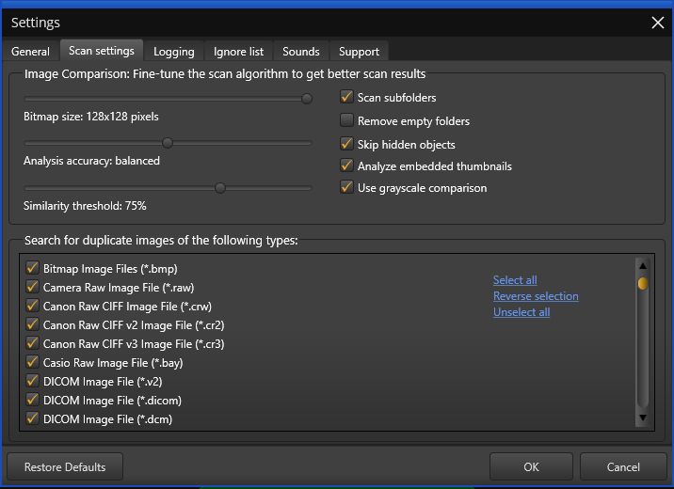

Figure 4 – Duplicate Photo CleanerTM settings panel – the Scan Settings tab

* **Bitmap size:** This slider enables you to set the bitmap size.
* **Analysis accuracy:** This slider enables you to set the threshold of the accuracy of analysis
* **Similarity threshold:** This slider enables you to set the threshold of the similarity being checked
* **Scan subfolders:** This checkbox enables you to set if sub-folders and their contents are to be check as well or not.
* **Remove empty folders:** This checkbox enables you to specify DPC to remove empty folders
* **Skip hidden objects:** This checkbox enables you to specify DPC to skip hidden items in a folder
* **Analyze embedded thumbnails:** This checkbox enables you to specify whether DPC has to analyze embedded thumbnails.
* **Use grayscale comparison:** This checkbox enables you to specify whether DPC uses grayscale comparison method to scan for duplicate images.
* **Search for duplicate images of following types:** This easel enables you to which types of images are to be scanned for judging by their filename extensions.
  + **Select all:** This link enables you to select all types of image types in this easel.
  + **Reverse selection:** This link enables you to deselect the currently selected image types & select the unselected image types.
  + **Unselect all:** This link enables you to unselect all types of image types in this easel.
* **Restore Defaults –** Clicking this button reverts all settings to the default mode of DPC.
* **OK –** Clicking this button saves the changes made and closes this panel
* **Cancel –** Clicking this button ignores the changes made and closes this panel

The Logging tab

The parameters on the Logging tab enable you to specify which events are to be logged and how may days of logs must be to be retained. Below are detailed descriptions of the Logging tab and its parameters as depicted in the figure below –

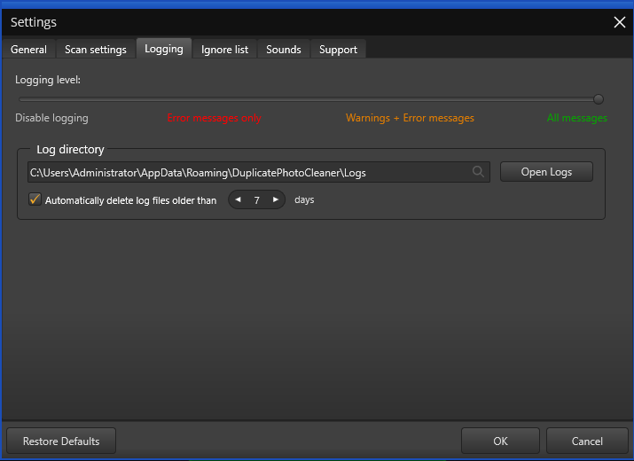

Figure 5 – Duplicate Photo CleanerTM settings panel – the Logging tab

* **Logging Level –** This slider enables you to set which types of application messages are to be logged (Disable logging / Error messages only / Warning + Error messages / All messages).
* **Log directory –** This field enables you to specify the path to the folder where all application message logs are to be stored
* **Open Logs –** Clicking this button enables you to view the contents of the logging folder where you can find all the application message logs.
* **Automatically delete log files older than X days:** This input control enables you to specify the number of days (X) for which the log files are to be retained. Files older than this value are discarded automatically for storage space optimization.
* **Restore Defaults –** Clicking this button reverts all settings to the default mode of DPC.
* **OK –** Clicking this button saves the changes made and closes this panel
* **Cancel –** Clicking this button ignores the changes made and closes this panel

The Ignore List tab

The parameters on the Ignore List tab enable you to specify which of the files within a folder to be scanned that DPC must ignore while performing the scan operation. As depicted in the figure below this exclusion list overrides any other options set within the DPC application. i.e. DPC application will not allow you to perform a scan, rename any contained file, and move or delete files in the specified folders.

**Warning:** You need to be extremely vigilant before performing a system wide scan. i.e. you must exclude all system folders as depicted in the figure below, before doing. It is not recommended to perform a system wide scan as this exposes vulnerabilities of unintended changes by the DPC application in case you miss out list any system folder.

Below are detailed descriptions of the Ignore List tab and its parameters as depicted in the figure below –

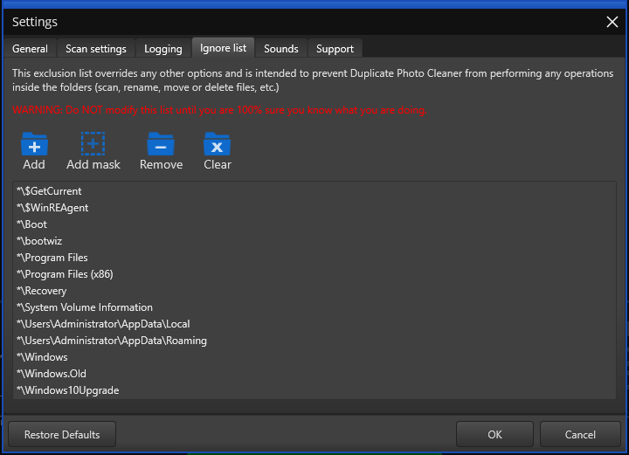

Figure 6 – Duplicate Photo CleanerTM settings panel – the Ignore List tab

* **Add –** Clicking this button enables you to add a folder to this ignore list
* **Add Mask –** Clicking this button enables you to add a string as a mask or wildcard entry to the ignore list. While performing a scan, DPC will check for any folder name containing this string and automatically ignore such a folder.
* **Remove –** After selecting a folder from the easel below, clicking this button enables you to remove that folder from this ignore list
* **Clear –** Clicking this button enables you to remove all specified folder in this ignore list
* **Restore Defaults –** Clicking this button reverts all settings to the default mode of DPC.
* **OK –** Clicking this button saves the changes made and closes this panel
* **Cancel –** Clicking this button ignores the changes made and closes this panel

The Sounds tab

The parameters on the Sounds tab enable you to specify the mp3 audio files to be played for each of the three events as described in the bulleted list below the figure. Below are detailed descriptions of the Sounds tab and its parameters as depicted in the figure below –

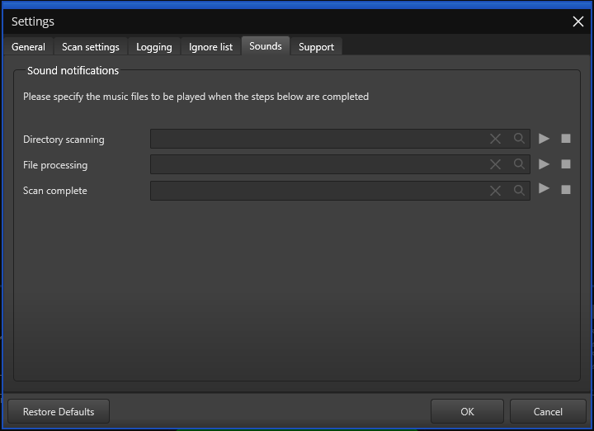

Figure 7 – Duplicate Photo CleanerTM settings panel – the Sounds tab

* **Directory scanning –** Clicking the Magnifying glass button enables you to navigate to an mp3 file which you can set for DPC to play when directory scanning is complete. Clicking the triangle Play button enables you to preview the mp3 audio file while the square Stop button stops the file you are previewing to stop playing.
* **File processing –** Clicking the Magnifying glass button enables you to navigate to an mp3 file which you can set for DPC to play when file processing is complete. Clicking the triangle Play button enables you to preview the mp3 audio file while the square Stop button stops the file you are previewing to stop playing.
* **Scan complete –** Clicking the Magnifying glass button enables you to navigate to an mp3 file which you can set for DPC to play when the specified scanning is complete. Clicking the triangle Play button enables you to preview the mp3 audio file while the square Stop button stops the file you are previewing to stop playing.
* **Restore Defaults –** Clicking this button reverts all settings to the default mode of DPC.
* **OK –** Clicking this button saves the changes made and closes this panel
* **Cancel –** Clicking this button ignores the changes made and closes this panel

The Support tab

The parameters on the Support tab enable you to prepare application specific detailed data in case your DPC application installation runs into an erroneous event. The Zip archive created by this tab is saved your system’s Documents folder which you can share with our support team. Below are detailed descriptions of the Support tab and its parameters as depicted in the figure below –

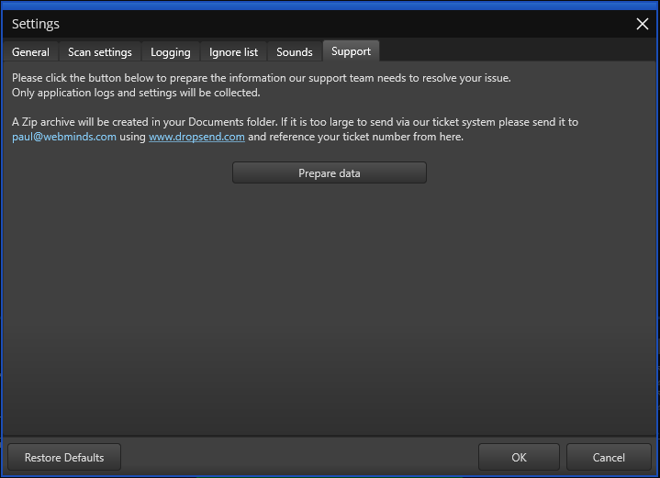

Figure 8 – Duplicate Photo CleanerTM settings panel – the Support tab

* **Prepare data –** Clicking this button collects all application specific data and saves it as a Zip archive in your system’s Documents folder which you can share with our support team.
* **Restore Defaults –** Clicking this button reverts all settings to the default mode of DPC.
* **OK –** Clicking this button saves the changes made and closes this panel
* **Cancel –** Clicking this button ignores the changes made and closes this panel

Limitations of Utilizing an Unregistered DPC Application in Trial Mode

The trial version of Duplicate Photo CleanerTM offers unlimited scanning for duplicates and similar images in all scan types. You can then delete up to 10 duplicate groups with the trial version.

This is why it makes more sense to purchase a license package as per your usage use case scenario.

The next chapter describes steps that enable you to **Register your DPC Application Installation**.

# Registering your DPC Application Installation

The steps described below enable you to place a **Buy Now** request of the Duplicate Photo CleanerTM application via the Duplicate Photo CleanerTM homepage –

You can place a **Register** request in the following 2 ways –

## Via the DPC Homepage

The steps described below enable you to register the DPC application via the DPC homepage –

1. From the DPC application homepage, click the **Support > Register Your Product** link available in the menu on the DPC TM homepage as depicted in the figure below –

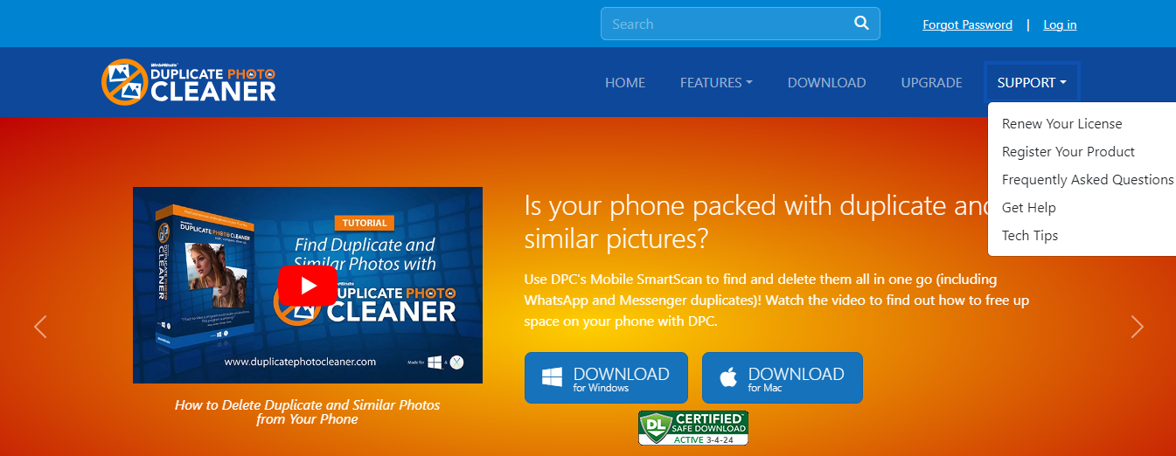

Figure 9 – Registering your DPC application installation via the DPCTM homepage

1. Click **Register** as depicted in the figure above. The register your software form is displayed as depicted in the figure below –

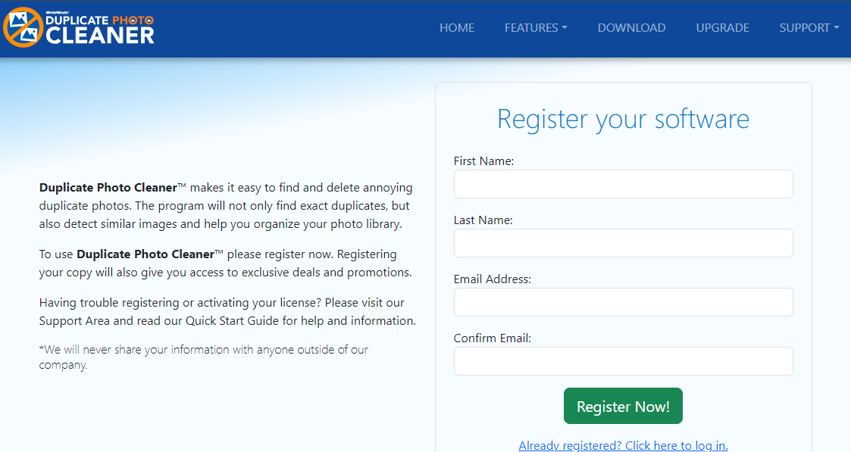

Figure 10 – Specifying your registration details

**Tip:** In case you have already registered, click the corresponding link provided under the **Register Now!** Button.

1. Specify your first name, last name, your email address, then confirm your email address & click **Register Now!**. The secure cart checkout page is displayed as depicted in the figure below –

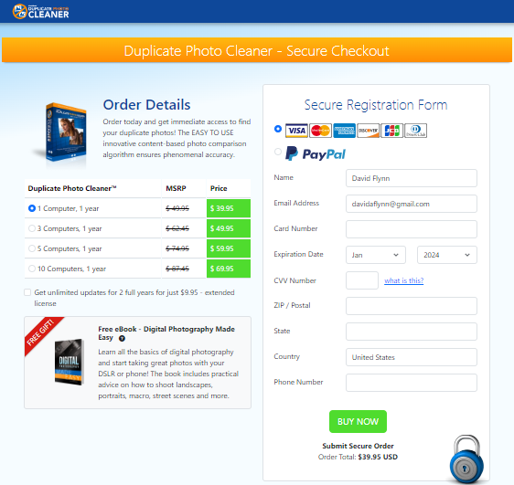

Figure 11 – Secure Registration page

1. Specify the required license options and your payment details & click **Buy Now**.

**Warning:** Ensure to double-check your specified details before you click **Buy Now**.

1. Once your payment details have been successfully processed, you will receive an email containing your DPCTM license key.

## Via the Register Button of DPC Application

The steps described below enable you to register the DPC application via the Register Button of DPC application –

1. After you launch the DPC application, the default screen is displayed as depicted in the figure below –

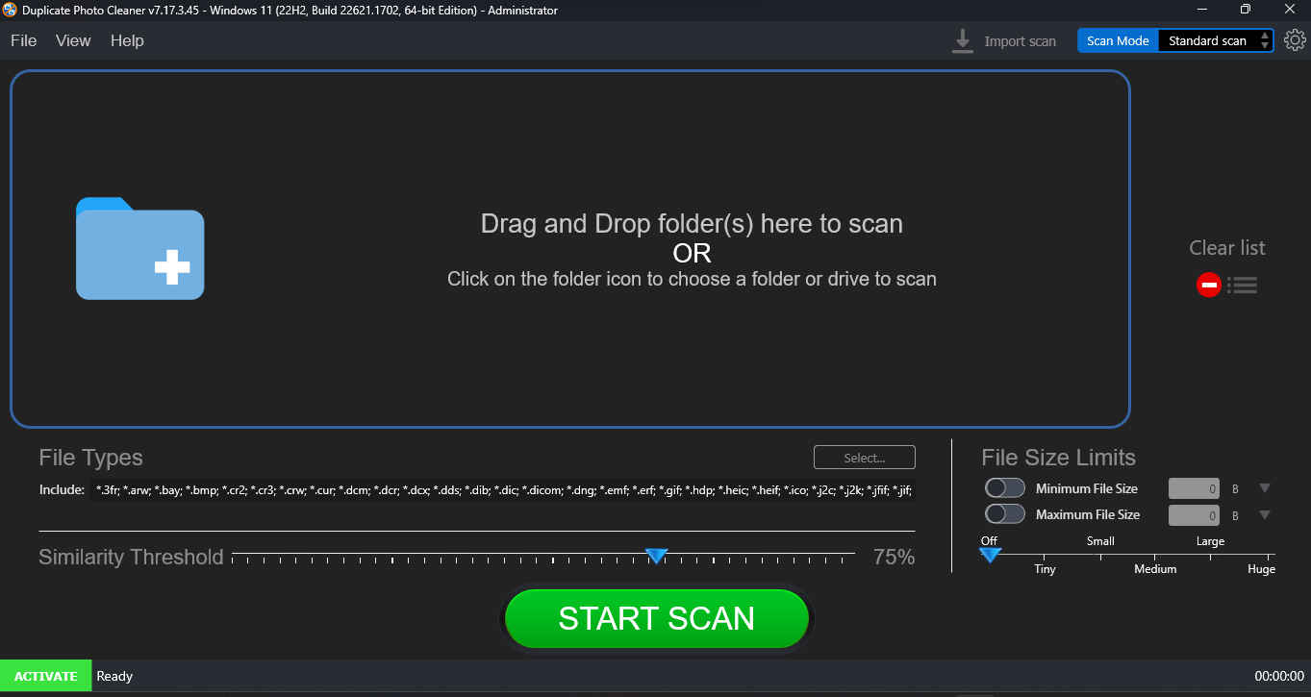

Figure 12 – DPC application default page

1. From the main toolbar menu, click **Help > About**. The DPC Product Key Details popup is displayed as depicted in the figure below –

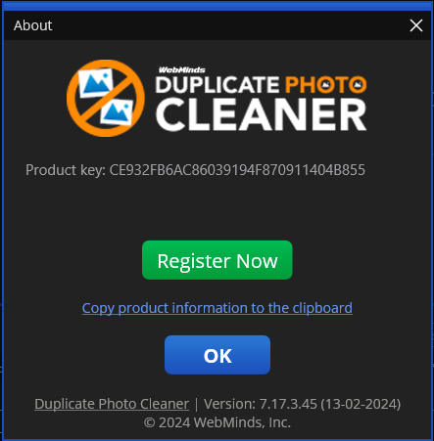

Figure 13 – DPC application license key specification – step 1

1. Click the **Register Now** button as depicted in the previous figure. The license registration key popup is displayed as depicted in the figure below –

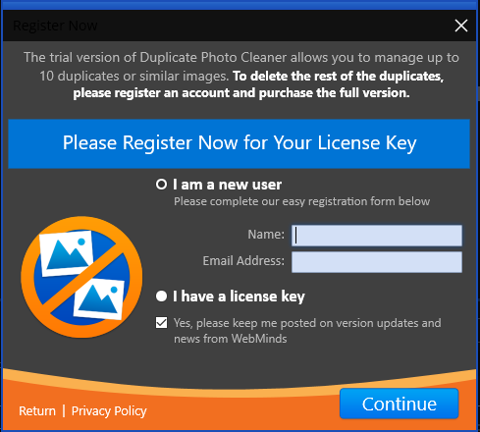

Figure 14 – DPC application license key specification – step 2

1. Specify your **Name** & **Email Address** and click **Continue**. You will receive your license details via email shortly. Also, the license registration key popup is displayed as depicted in the figure below –

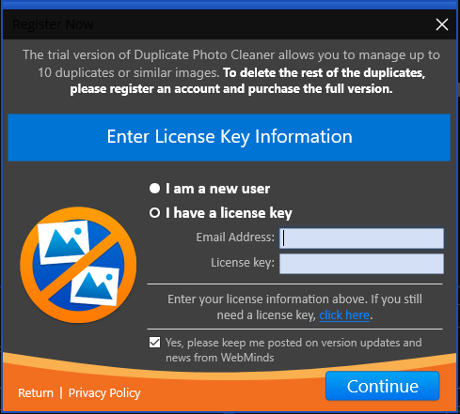

Figure 15 – DPC application license key specification – step 3

**Tip:** In case you haven’t received your license as yet, you can close this popup and continue exploring the DPC application. Once you receive your license details, follow the steps described in **Activating your DPC Installation** chapter.

1. If you have received your license details, specify your **Email Address** & **License Key** and click **Continue**. Your license key will be validated with our records and a successful activation popup message will be displayed as depicted in the figure below –

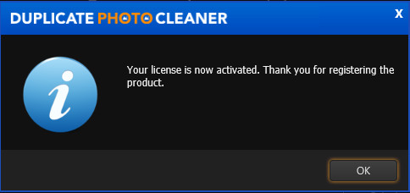

Figure 16 – DPC application license key activation successful

1. Click **OK** to continue. Now the 10-item duplicate photo limit will be removed and you can utilize all features of this application freely without any limitations.

The next chapter describes steps that enable you to **Activate your DPC Application**.

# Activating your DPC Installation

In case you have not activated your Duplicate Photo CleanerTM application as yet, you can utilize the steps described below –

1. After you launch the DPC application, the default screen is displayed as depicted in the figure below –



Figure 17 – DPC application default screen

1. From the main toolbar menu, click **Help > About**. The DPC Product Key Details popup is displayed as depicted in the figure below –



Figure 18 – Activating DPC application – step 1

1. Click the **Register Now** button as depicted in the previous figure. The license registration key popup is displayed as depicted in the figure below –



Figure 19 – Activating DPC application – step 2

1. Specify your **Name** & **Email Address** and click **Continue**. You will be redirected to the DPC Secure Checkout page. Using this webpage, you can specify a subscription plan of your choice, specify your identification details as required by this page, and make your payment. Post this, we will send you your license key on the email address that you specified on the registration popup.

The next chapter describes steps that enable you to **Remove your DPC License Key details**.

# Removing your DPC License Details

In case you intend to remove your DPC application license details so that you can use it on another system, you can utilize the steps described below –

**Warning:** You can only activate & remove your DPC license details 3 times post which this license will automatically expire.

1. After you launch the DPC application, the default screen is displayed as depicted in the figure below –



Figure 20 – DPC application default screen

1. From the main toolbar menu, click **Help > About**. The DPC Product Key Details popup is displayed as depicted in the figure below –

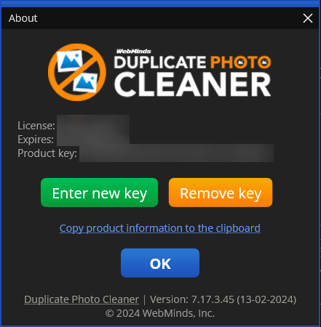

Figure 21 – Removing DPC application license key details – About popup

1. Click the **Remove Key** button as depicted in the previous figure. The license key removal confirmation popup is displayed as depicted in the figure below –

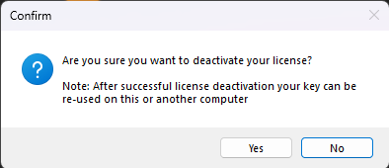

Figure 22 – Removing license key details confirmation popup

1. Click the **Yes** button. A successful license key removal confirmation messages is displayed as depicted in the figure below –

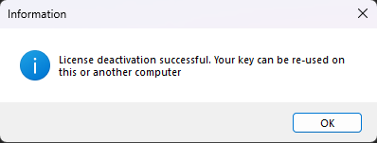

Figure 23 – Successful Removal of DPC application license key details

1. Click **OK** to continue. Now you can reuse this license key on another computer.

**Warning:** You can only activate & remove your DPC license details 3 times post which this license will automatically expire.

The next chapter describes steps that enable you to **Perform a Standard Scan**.

# Performing a Standard Scan

The steps described below enable you to perform offline data migration –

1. After you launch the Duplicate Photo CleanerTM application on your first or older PC, the default screen is displayed as depicted in the figure below –

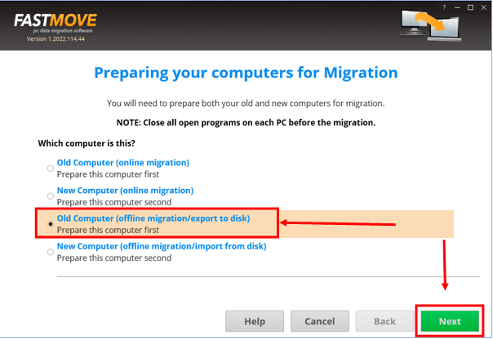

Figure 24 – Performing offline data migration

1. Select the **Old Computer (offline migration/export to disk)** option & click **Next**. The folder specification page is displayed as depicted in the figure below –

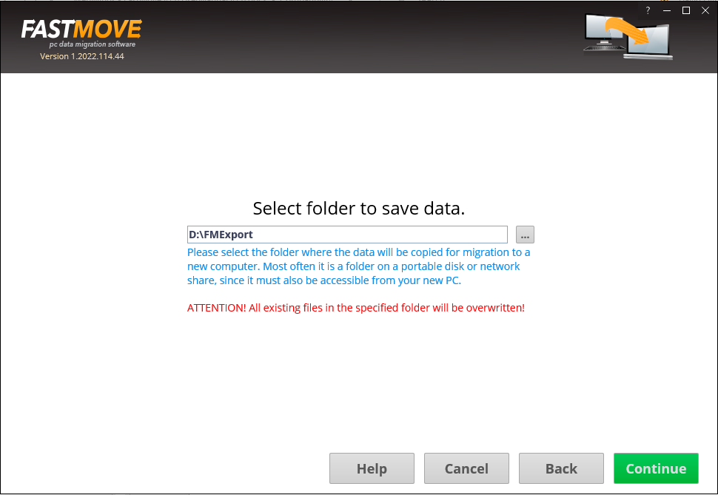

Figure 25 – Selecting a folder

**Tip:** Typically, this will be your external storage location.

1. Specify the folder to export your data by using the **Ellipsis (…)** button & click **Continue**. The custom file page is displayed as depicted in the figure below –

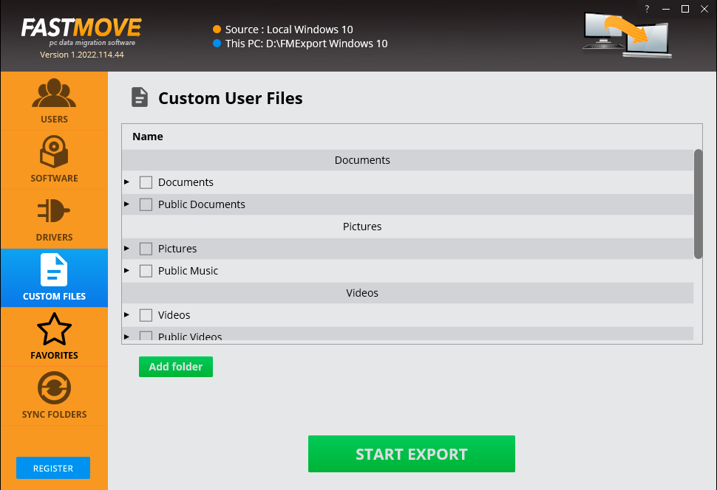

Figure 26 – Exporting you data folders & files

1. Select the folders that you intend to export and click **Start Export**.

Tip: You can specify more folders in case they are not available in this list by clicking **Add Export**.

The specified folder will be exported to the external storage location that you specified in step 2 in this section.

1. Now attach your external storage location to your second PC and launch the Duplicate Photo CleanerTM application.
2. After you launch the Duplicate Photo CleanerTM application on your second or newer PC, the default screen is displayed as depicted in the figure below –

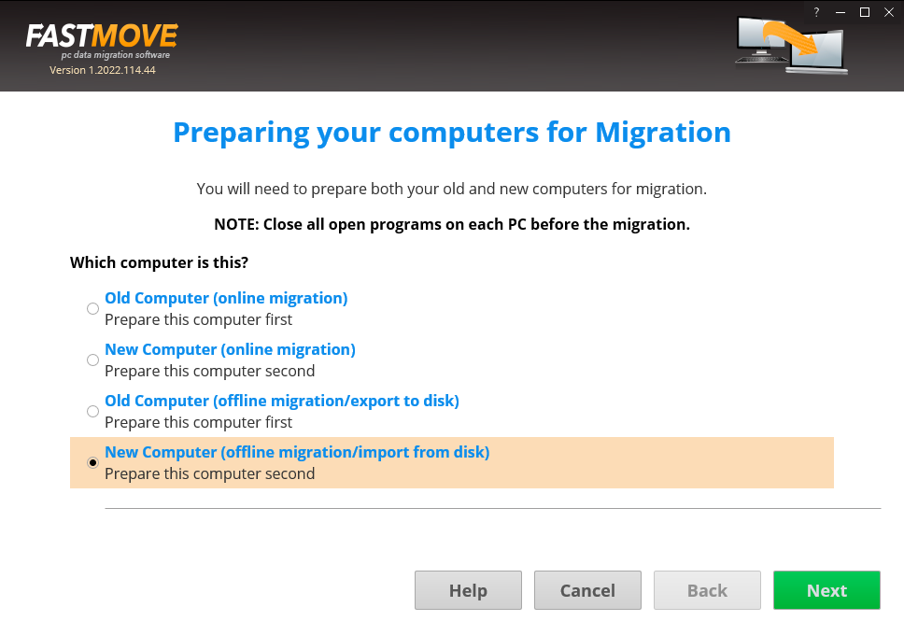

Figure 27 – Performing offline data migration

1. Select the **New Computer (offline migration/import from disk)** option & click **Next**. The folder specification page is displayed as depicted in the figure below –

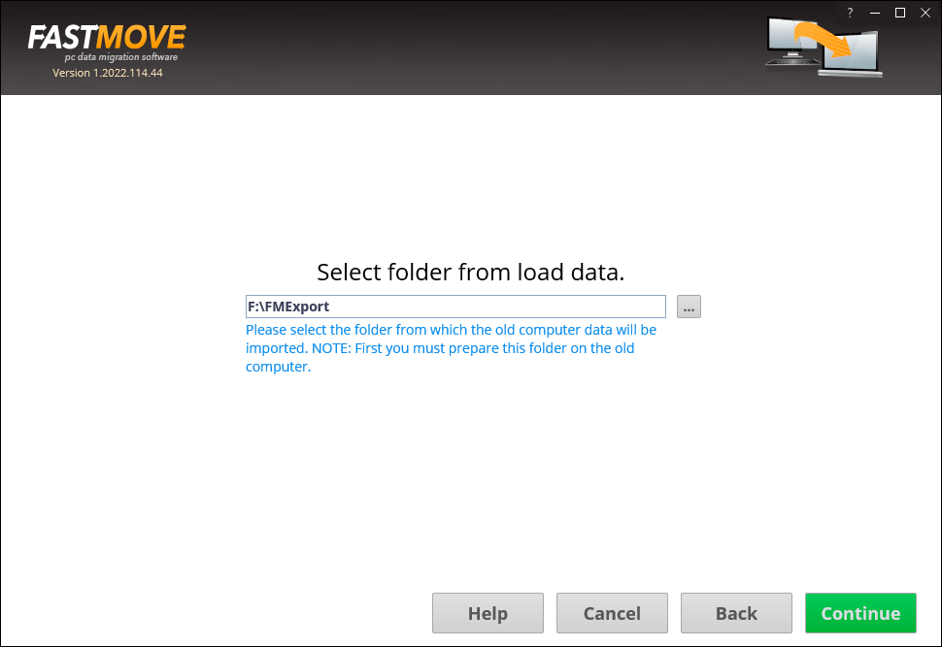

Figure 28 – Selecting a folder

**Tip:** Typically, this will be your external storage location.

1. Specify the folder to import your data from by using the **Ellipsis (…)** button & click **Continue**. The custom file page is displayed as depicted in the figure below –

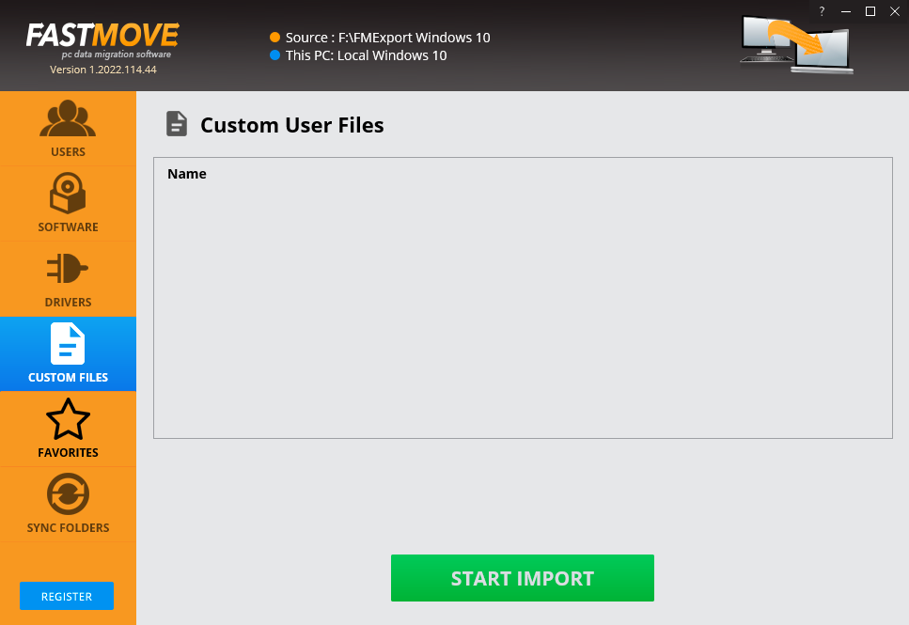

Figure 29 – Importing your data files & folders

1. Click **Start Import**. The specified folder will be imported to you second or new PC and a confirmation message will also be displayed.

**Tip:** Your files will be imported at the same path as your first or older PC.

The next chapter describes steps that enable you to **Perform Online Data Migration**.

# Performing a Mobile SmartScan

The steps described below enable you to perform online data migration –

1. Connect both your old & new PCs to the same network.

**Tip:** Ensure that both these PCs are discoverable to each other. Consult your network administrator or Windows Support. You may also require ensuring that you allow Duplicate Photo CleanerTM through the Windows Firewall on both PCs.

1. After you launch the Duplicate Photo CleanerTM application on your first or older PC, the default screen is displayed as depicted in the figure below –

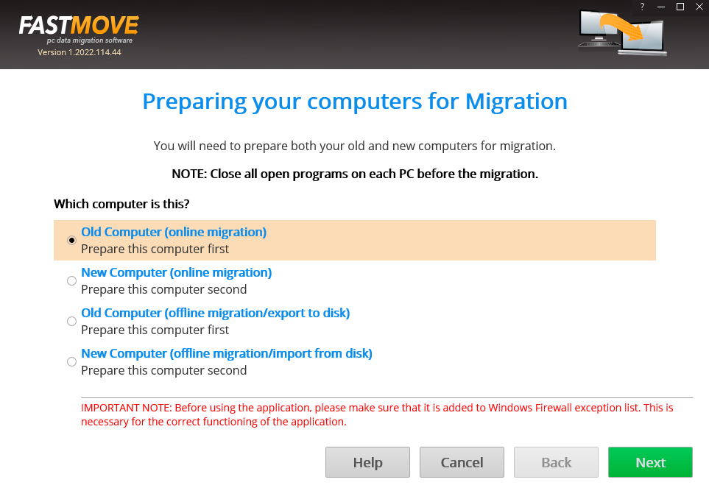

Figure 30 – Performing online data migration – PC1

1. Select the **Old Computer (offline migration/export to disk)** option on the first or old PC & click **Next**. Your IP Address details page is displayed as depicted in the figure below –

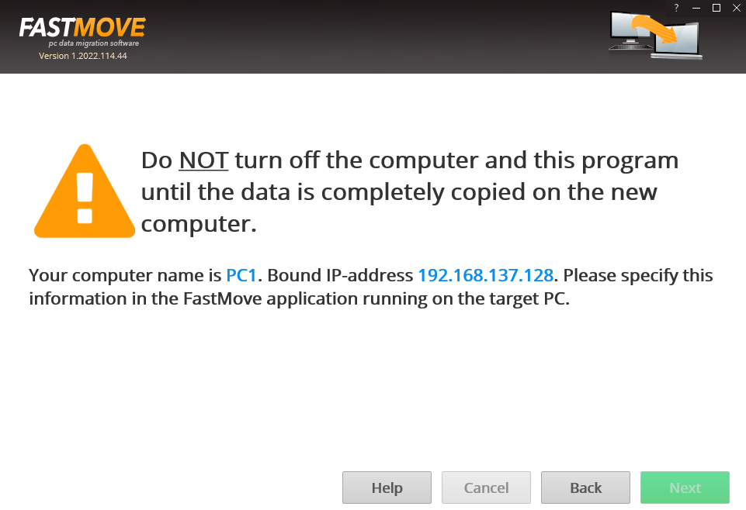

Figure 31 – Performing online data migration – PC2

1. Now on your second or newer PC, select the **New Computer (online migration)** option & click **Next** from the default screen is displayed as depicted in the figure below –

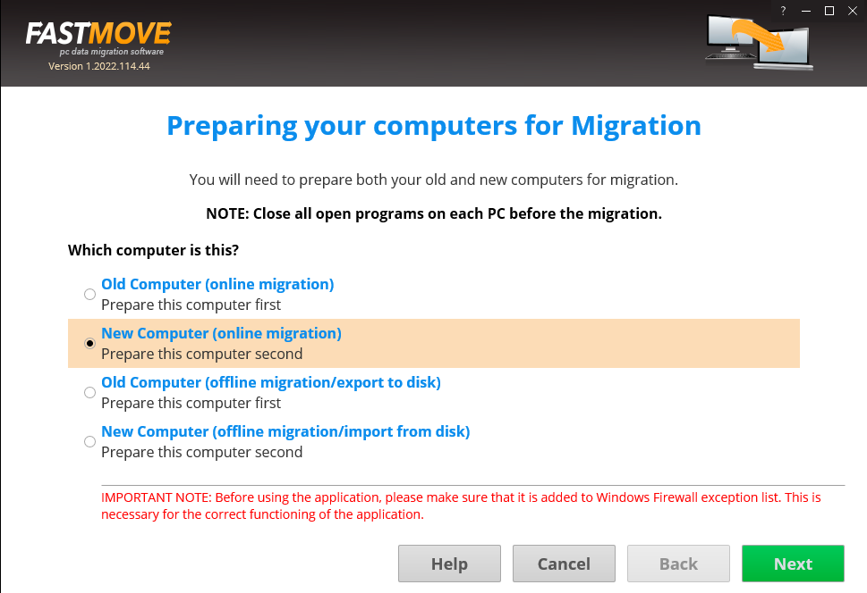

Figure 32 – Performing online data migration – PC2

The Duplicate Photo CleanerTM application will scan your network in order to look for your first or old PC automatically.

1. After your network has been successfully scanned, the IP Address details specification windows will be displayed as depicted in the figure below –

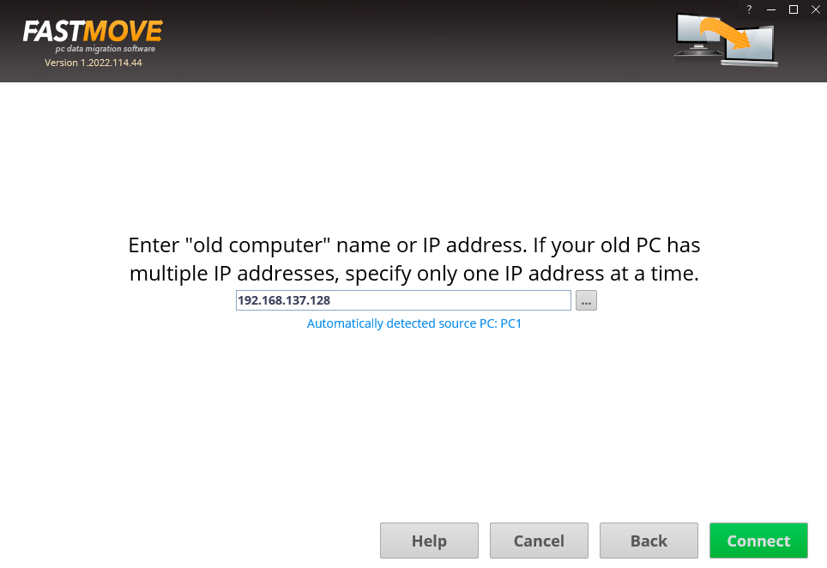

Figure 33 – Specifying the IP Adress of your second or newer PC

**Tip:** In case you do not see an automatically detected PC, consult your network administrator or Windows Support. You can also specify another IP Address in case you have multiple PCs connected to your network via the Duplicate Photo CleanerTM application by clicking the **Ellipses (…)** button.

1. Click **Connect**. The custom files window is displayed a depicted in the figure below –

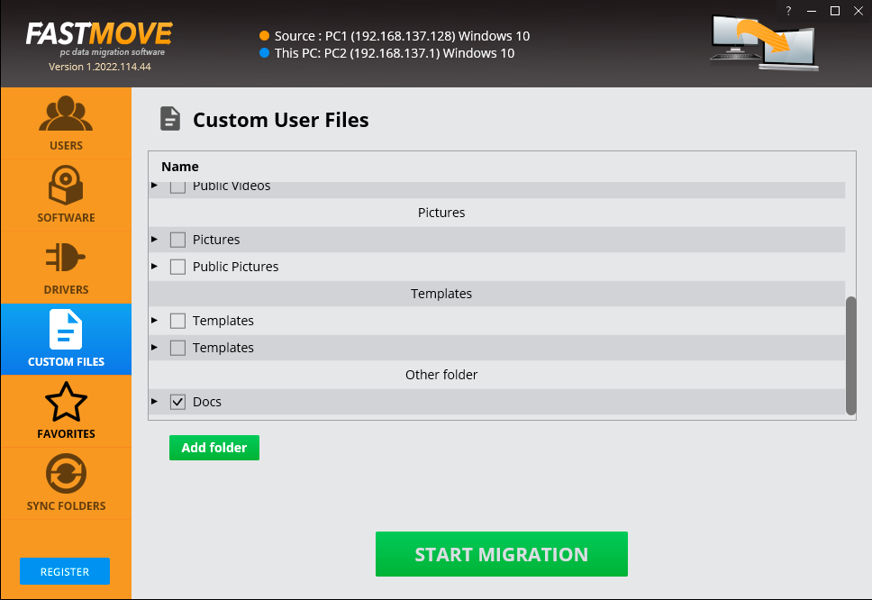

Figure 34 – Specifying the data folders & files to migrate from your first or older PC to your second or newer PC

1. Specify the folder to import your data from this dialog box or by clicking **Add Folder** button. The custom file page is displayed as depicted in the figure below –

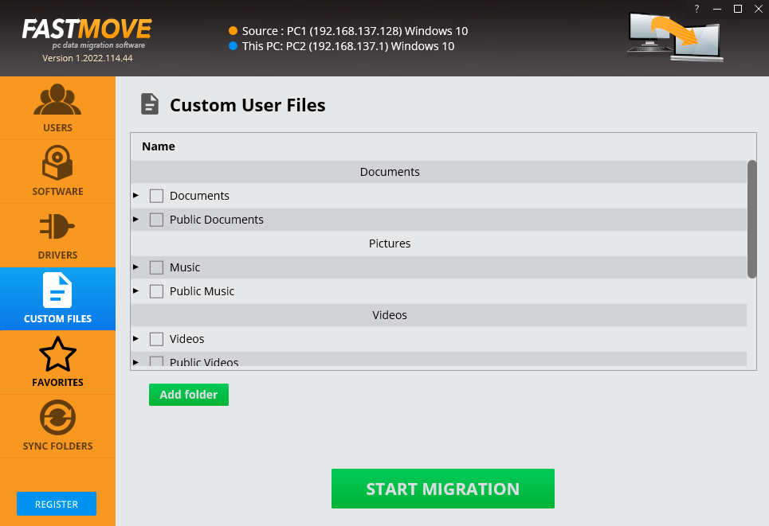

Figure 35 – Importing your data folders & files

Your files will be selected as depicted in the figure below –



Figure 36 – Selected data folders & files

1. Click **Start Migration**. Your data folders & files will be migrated and a confirmation message will be displayed as depicted in the figure below –

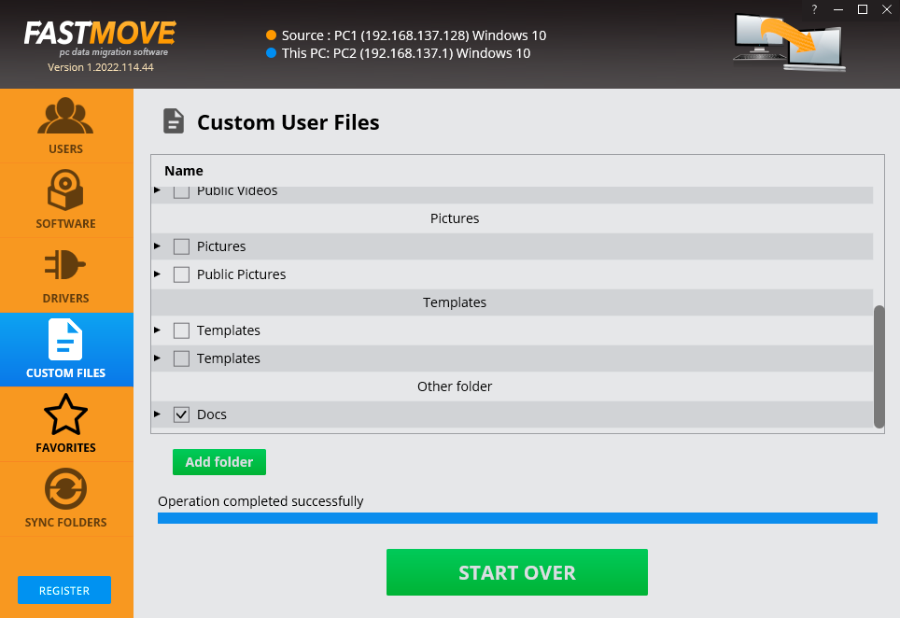

Figure 37 – Selected data folders & files

**Tip:** You can click **Start Over** to specify more data folders or files.

The next chapter describes steps that enable you to **Activate your Duplicate Photo CleanerTM installation**.

# Performing a Folder Comparison

Now that you have successfully registered & activated your Duplicate Photo CleanerTM application license key details, you can follow steps described in the **Performing**  chapter to migrate your users in the offline.

The steps described below enable you to perform users migration using the online method to save time, efforts, & reduce the number of migration iterations –

1. Connect both your old & new PCs to the same network.

**Tip:** Ensure that both these PCs are discoverable to each other. Consult your network administrator or Windows Support. You may also require ensuring that you allow Duplicate Photo CleanerTM through the Windows Firewall on both PCs.

1. After you launch the Duplicate Photo CleanerTM application on your first or older PC, the default screen is displayed as depicted in the figure below –



Figure 38 – Performing online data migration – PC1

1. Select the **Old Computer (offline migration/export to disk)** option on the first or old PC & click **Next**. Your IP Address details page is displayed as depicted in the figure below –



Figure 39 – Performing online data migration – PC2

1. Now on your second or newer PC, select the **New Computer (online migration)** option & click **Next** from the default screen is displayed as depicted in the figure below –



Figure 40 – Performing online data migration – PC2

The Duplicate Photo CleanerTM application will scan your network in order to look for your first or old PC automatically.

1. After your network has been successfully scanned, the IP Address details specification windows will be displayed as depicted in the figure below –



Figure 41 – Specifying the IP Adress of your second or newer PC

**Tip:** In case you do not see an automatically detected PC, consult your network administrator or Windows Support. You can also specify another IP Address in case you have multiple PCs connected to your network via the Duplicate Photo CleanerTM application by clicking the **Ellipses (…)** button.

1. Click **Connect**. The users window is displayed a depicted in the figure below –

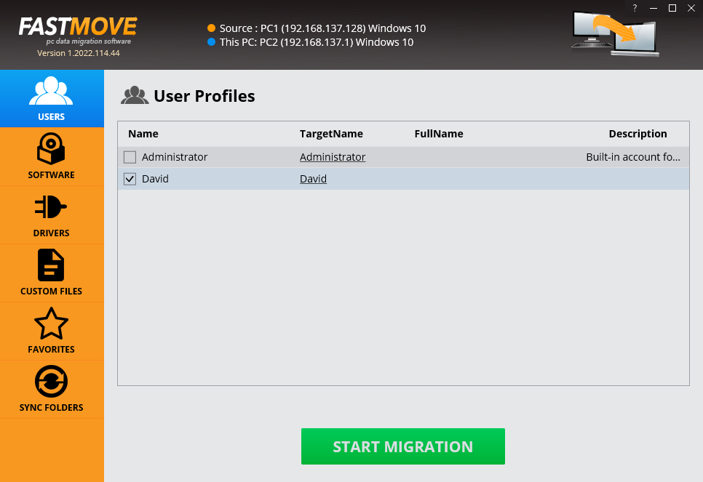

Figure 42 – Specifying the users to migrate from your first or older PC to your second or newer PC

1. Click **Start Migration**. The selected users will be migrated & a confirmation message will also be displayed on the screen.

The next chapter describes steps that enable you to **Perform Software Migration**.

# Performing a Picassa Scan

Now that you have successfully registered & activated your Duplicate Photo CleanerTM application license key details, you can follow steps described in the **Performing**  chapter to migrate your software in the offline mode in case you have an external storage device large enough to hold all your software.

The steps described below enable you to perform software migration using the online method to save time, efforts, & reduce the number of migration iterations –

1. Connect both your old & new PCs to the same network.

**Tip:** Ensure that both these PCs are discoverable to each other. Consult your network administrator or Windows Support. You may also require ensuring that you allow Duplicate Photo CleanerTM through the Windows Firewall on both PCs.

1. After you launch the Duplicate Photo CleanerTM application on your first or older PC, the default screen is displayed as depicted in the figure below –



Figure 43 – Performing online data migration – PC1

1. Select the **Old Computer (offline migration/export to disk)** option on the first or old PC & click **Next**. Your IP Address details page is displayed as depicted in the figure below –



Figure 44 – Performing online data migration – PC2

1. Now on your second or newer PC, select the **New Computer (online migration)** option & click **Next** from the default screen is displayed as depicted in the figure below –



Figure 45 – Performing online data migration – PC2

The Duplicate Photo CleanerTM application will scan your network in order to look for your first or old PC automatically.

1. After your network has been successfully scanned, the IP Address details specification windows will be displayed as depicted in the figure below –



Figure 46 – Specifying the IP Adress of your second or newer PC

**Tip:** In case you do not see an automatically detected PC, consult your network administrator or Windows Support. You can also specify another IP Address in case you have multiple PCs connected to your network via the Duplicate Photo CleanerTM application by clicking the **Ellipses (…)** button.

1. Click **Connect**. The users window is displayed a depicted in the figure below –

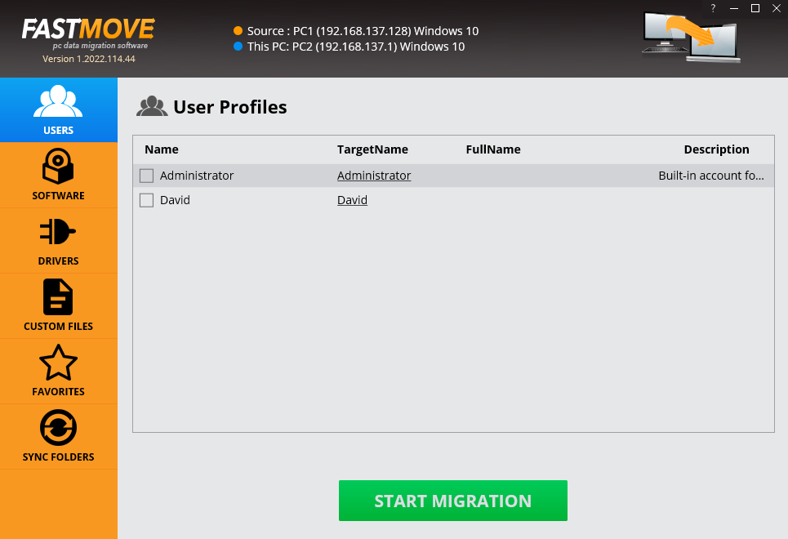

Figure 47 – Users screen

1. Then click **Software** from the left panel. The software window is displayed as depicted in the figure below –

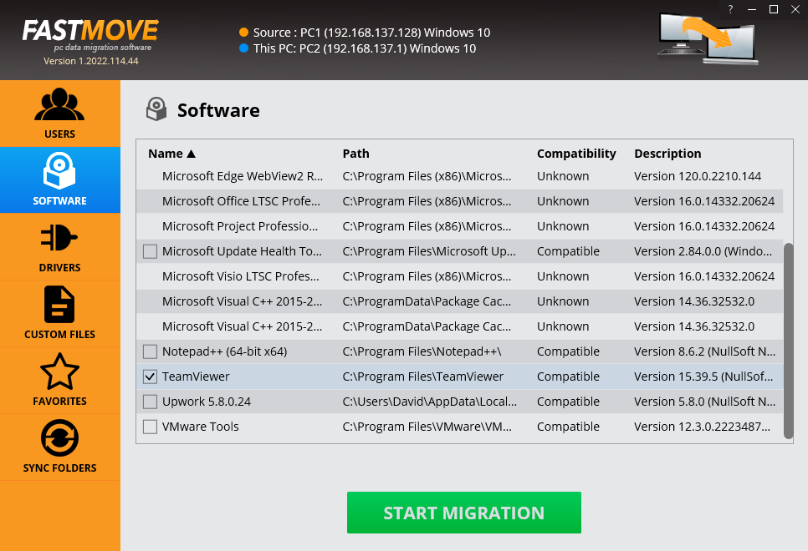

Figure 48 – Importing your software

1. Select the software you intend to migrate & click **Start Migration**. The selected software will be migrated & a confirmation message will also be displayed on screen.

The next chapter describes steps that enable you to **Perform Drivers Migration**.

# Performing a Lightroom Classic Scan

Now that you have successfully registered & activated your Duplicate Photo CleanerTM application license key details, you can follow steps described in the **Performing**  chapter to migrate your drivers in the offline mode in case you have an external storage device large enough to hold all your drivers.

The steps described below enable you to perform drivers migration using the online method to save time, efforts, & reduce the number of migration iterations –

1. Connect both your old & new PCs to the same network.

**Tip:** Ensure that both these PCs are discoverable to each other. Consult your network administrator or Windows Support. You may also require ensuring that you allow Duplicate Photo CleanerTM through the Windows Firewall on both PCs.

1. After you launch the Duplicate Photo CleanerTM application on your first or older PC, the default screen is displayed as depicted in the figure below –



Figure 49 – Performing online data migration – PC1

1. Select the **Old Computer (offline migration/export to disk)** option on the first or old PC & click **Next**. Your IP Address details page is displayed as depicted in the figure below –



Figure 50 – Performing online data migration – PC2

1. Now on your second or newer PC, select the **New Computer (online migration)** option & click **Next** from the default screen is displayed as depicted in the figure below –



Figure 51 – Performing online data migration – PC2

The Duplicate Photo CleanerTM application will scan your network in order to look for your first or old PC automatically.

1. After your network has been successfully scanned, the IP Address details specification windows will be displayed as depicted in the figure below –



Figure 52 – Specifying the IP Adress of your second or newer PC

**Tip:** In case you do not see an automatically detected PC, consult your network administrator or Windows Support. You can also specify another IP Address in case you have multiple PCs connected to your network via the Duplicate Photo CleanerTM application by clicking the **Ellipses (…)** button.

1. Click **Connect**. The users window is displayed a depicted in the figure below –



Figure 53 – Users screen

1. Now click **Drivers** from the left panel. The drivers window is displayed as depicted in the figure below –

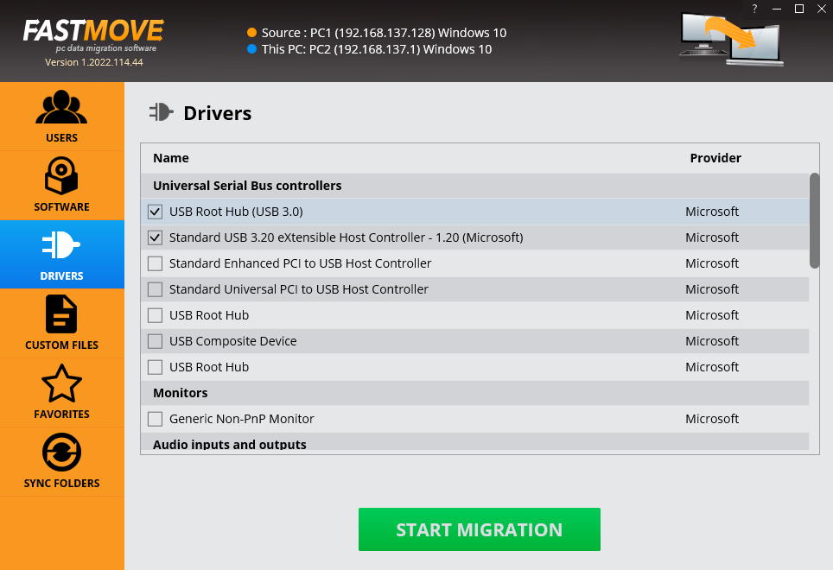

Figure 54 – Importing your drivers

1. Select the drivers that you intend to migrate & click **Start Migration**. The selected drivers will be migrated & a confirmation message will also be displayed on screen.

The next chapter describes steps that enable you to **Perform Favorites Migration**.

# Performing a PaintShop Pro Scan

Now that you have successfully registered & activated your Duplicate Photo CleanerTM application license key details, you can follow steps described in the **Performing**  chapter to migrate your favorites in the offline mode in case you have an external storage device large enough to hold all your favorites.

The steps described below enable you to perform favorites migration using the online method to save time, efforts, & reduce the number of migration iterations –

1. Connect both your old & new PCs to the same network.

**Tip:** Ensure that both these PCs are discoverable to each other. Consult your network administrator or Windows Support. You may also require ensuring that you allow Duplicate Photo CleanerTM through the Windows Firewall on both PCs.

1. After you launch the Duplicate Photo CleanerTM application on your first or older PC, the default screen is displayed as depicted in the figure below –



Figure 55 – Performing online data migration – PC1

1. Select the **Old Computer (offline migration/export to disk)** option on the first or old PC & click **Next**. Your IP Address details page is displayed as depicted in the figure below –



Figure 56 – Performing online data migration – PC2

1. Now on your second or newer PC, select the **New Computer (online migration)** option & click **Next** from the default screen is displayed as depicted in the figure below –



Figure 57 – Performing online data migration – PC2

The Duplicate Photo CleanerTM application will scan your network in order to look for your first or old PC automatically.

1. After your network has been successfully scanned, the IP Address details specification windows will be displayed as depicted in the figure below –



Figure 58 – Specifying the IP Adress of your second or newer PC

**Tip:** In case you do not see an automatically detected PC, consult your network administrator or Windows Support. You can also specify another IP Address in case you have multiple PCs connected to your network via the Duplicate Photo CleanerTM application by clicking the **Ellipses (…)** button.

1. Click **Connect**. The users window is displayed a depicted in the figure below –



Figure 59 – User screen

1. Now click **Favorites** from the left panel. The favorites window is displayed as depicted in the figure below –

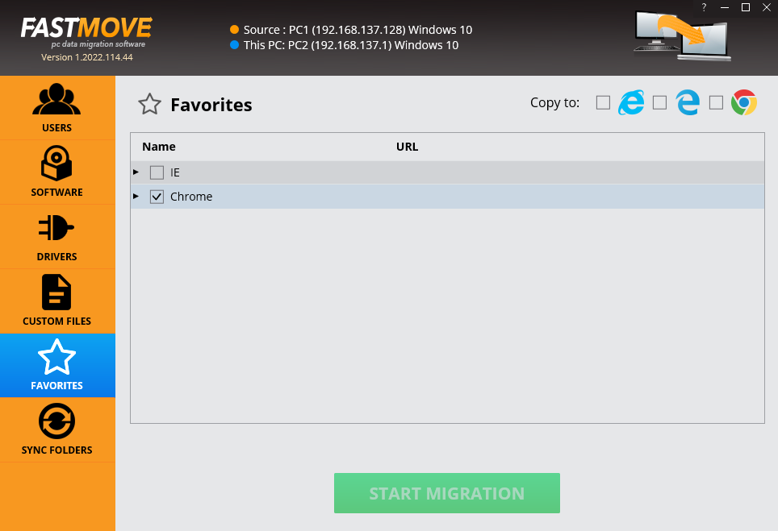

Figure 60 – Importing your favorites from your default browser

1. Select the favorites that you intend to migrate & click **Start Migration**. Your selected favorites will be migrated & a confirmation message will be on screen.

The next section of this user manual **Frequently Asked Questions (FAQs)** as an appendix.

# Performing a Fragment Search

Now that you have successfully registered & activated your Duplicate Photo CleanerTM application license key details, you can follow steps described in the **Performing**  chapter to migrate your favorites in the offline mode in case you have an external storage device large enough to hold all your favorites.

The steps described below enable you to perform favorites migration using the online method to save time, efforts, & reduce the number of migration iterations –

1. Connect both your old & new PCs to the same network.

**Tip:** Ensure that both these PCs are discoverable to each other. Consult your network administrator or Windows Support. You may also require ensuring that you allow Duplicate Photo CleanerTM through the Windows Firewall on both PCs.

1. After you launch the Duplicate Photo CleanerTM application on your first or older PC, the default screen is displayed as depicted in the figure below –



Figure 61 – Performing online data migration – PC1

1. Select the **Old Computer (offline migration/export to disk)** option on the first or old PC & click **Next**. Your IP Address details page is displayed as depicted in the figure below –



Figure 62 – Performing online data migration – PC2

1. Now on your second or newer PC, select the **New Computer (online migration)** option & click **Next** from the default screen is displayed as depicted in the figure below –



Figure 63 – Performing online data migration – PC2

The Duplicate Photo CleanerTM application will scan your network in order to look for your first or old PC automatically.

1. After your network has been successfully scanned, the IP Address details specification windows will be displayed as depicted in the figure below –



Figure 64 – Specifying the IP Adress of your second or newer PC

**Tip:** In case you do not see an automatically detected PC, consult your network administrator or Windows Support. You can also specify another IP Address in case you have multiple PCs connected to your network via the Duplicate Photo CleanerTM application by clicking the **Ellipses (…)** button.

1. Click **Connect**. The users window is displayed a depicted in the figure below –



Figure 65 – User screen

1. Now click **Favorites** from the left panel. The favorites window is displayed as depicted in the figure below –



Figure 66 – Importing your favorites from your default browser

1. Select the favorites that you intend to migrate & click **Start Migration**. Your selected favorites will be migrated & a confirmation message will be on screen.

The next section of this user manual **Frequently Asked Questions (FAQs)** as an appendix.

1. Frequently Asked Questions (FAQs)

Here is a list of frequently asked questions with reference to the Duplicate Photo CleanerTM application and its usage –

Why do I need Duplicate Photo Cleaner™?

Duplicate Photo CleanerTM is the app that makes it easy to move all your files, user profiles, settings, software and even drivers from one computer to another. It's perfect for configuring a new computer with all your stuff, syncing folders, and keeping data and settings the same on two or more computers.

1. How do I install Duplicate Photo CleanerTM on a Windows PC?

Tip: Refer to section 1.1 – Downloading the DPC Application Installer

I have folders with intentional copies of my photos that I use as backups. How can I exclude them from DPC's scans?

You'll need to add these folders to the Ignore List. To do that, go to Settings, click on the Ignore List tabs and add the folders you want to exclude from scans.

What are the trial version limitations?

The trial version of Duplicate Photo CleanerTM offers unlimited scanning for duplicates and similar images. You can then delete up to 10 duplicate groups with the trial version.

I thought I had purchased a license for 3 computers, but it looks like I've purchased a single-PC license. Is there any way to upgrade my license for the price difference between the two?

Please log into your account from [this](https://www.duplicatephotocleaner.com/login) page. To the right of your license key, you'll see two links – to renew and to upgrade. Click on the Upgrade button and follow the prompts.

I want to install Duplicate Photo CleanerTM on another computer using my current license key. Is that possible?

If you ever need to reinstall Duplicate Photo CleanerTM or move it to a different computer, you should copy your license key and unregister the program before you do anything else. To do that click on "Help" and go to the "About" screen inside the program. Then make a note of your license key and remove the key. This will reset the license so that you can reactivate it on a new installation (this feature is limited to 3 times).

**Note:** if your license key has expired, please visit the Version History page on the site and download the version that was released before your key expired. An expired key will not activate any version released after the key's expiration.

**Tip:** For more information, refer to Activating your DPC Installation and Removing your DPC License Details chapters.

My computer is not connected to the Internet. Is there a way to activate Duplicate Photo CleanerTM offline?

Follow these steps to activate Duplicate Photo CleanerTM on a computer that's not connected to the Internet:

1. Purchase a license key and install Duplicate Photo CleanerTM on your computer.
2. Open Duplicate Photo CleanerTM, click on Help in the menu and go to "About".
3. Copy the product key from the popup that appears.
4. Go to [this](https://www.duplicatephotocleaner.com/support) page and open a support ticket. Make sure you send both your product key and your license key to the Support Team.
5. Our Support Team will generate activation data for your copy of Duplicate Photo CleanerTM and email it to you.
6. Copy the activation data from the email, save it as a text file and put the file on a flash drive.
7. Connect the flash drive to your offline computer, open the text file with the activation data, select all of it and copy it. Important: don't paste it anywhere at this point!
8. Open Duplicate Photo CleanerTM. If you have valid activation data and if you've followed these steps correctly, your copy of Duplicate Photo CleanerTM will become activated.

If you're on Windows, you can ask the Support Team to email you a Master File that you can save to the folder where Duplicate Photo CleanerTM is installed. Then simply open Duplicate Photo CleanerTM and it will get activated.

I'm updating to Windows 10. Will your software continue to work?

We've become aware of a Duplicate Photo CleanerTM registration glitch that some people experience when they update to Windows 10. We've investigated the problem and found a solution. So, if you are planning to update to Windows 10, please follow these steps before you run the update:

1. Open Duplicate Photo CleanerTM and click on "About" in the top right corner
2. Make a note of your registration code, then select "Remove key" and close the program
3. Update your operating system to Windows 10
4. Open Duplicate Photo CleanerTM again and click on the "Register Now" button
5. Close the Web page that opens (you don't need that page because you already have your license code)
6. Enter your license code and the e-mail address you used to register in a pop-up window that appears
7. Click "Activate" and continue to enjoy Duplicate Photo CleanerTM

What formats does Duplicate Photo CleanerTM support?

Duplicate Photo Cleaner supports BMP, JPG, JPEG, JFIF, PNG, TIF, TIFF, GIF, ICO, WMP, ICNS, PSD, TGA, RAW, CRW, CR2, CR3, NEF, PEF, RAF, X3F, BAY, ORF, SRF, MRW, DCR, SR2, DNG, RW2, ARW, HEIC, HEIF, 3FR, DCX, DIB, EMF, JPS, HDP, PBM, PGM, PNS, PPM, PCT, CUR, WEBP, BAY, ERF, KDC, RWL, MEF, NRW, PTX, SRW, RLE, DDS, WDP, JXR, HDP, JPE, JIF, J2K, JPC, J2C, JP2, PCX, SVG, DCM, DIC, DICOM and V2.

How do I configure Duplicate Photo CleanerTM to detect only exact duplicates?

All you need to do is set the image similarity threshold to 100%. To do that, open the program and click on Settings. In the new window go to the File Search tab and move the image similarity threshold slider to 100%. Click OK to save your settings.

How can I get more information about the images?

Setting the scan results view to tree view will make the program display information like image width and height, size and modification date in addition to image location. To change your view settings to tree view, click on the View result menu item and select as Tree.

I want to scan for duplicate JPG images only. How can I prevent the program from detecting GIF, BMP and PNG files?

Simply go to program settings, navigate to the File Search tab and uncheck BMP, GIF and PNG. Click OK to save your settings.

What is the benefit of comparing photos in grayscale?

Comparing photos in grayscale will help you get more matches without lowering the image similarity threshold. When you search for duplicate and similar photos in grayscale as opposed to in full color, Duplicate Photo CleanerTM disregards color changes. This method allows you to find more duplicate photos and more similar images you may want to move or delete.

To compare photos in grayscale, go to Duplicate Photo CleanerTM settings and check "Use grayscale comparison" on the File Search tab.

What is Sector Detail Scan and how does it work?

Sector Detail Scan is a scan mode introduced in Duplicate Photo CleanerTM 2.8. This mode lets you select a sector on an image and search other images for that particular sector. Here is how to use it:

1. Select "Sector Detail Scan" as your scan mode
2. Select the folders you want to scan for similar images
3. Add a photo and select a sector on it that you want to find in other images
4. Start the scan

Because Sector Detail Scan is very precise, it can take several hours to complete the scan. To make your scans faster, we suggest that you set the similarity threshold to 50% and scan smaller folders.

What is the difference between Easy Duplicate Finder™ and Duplicate Photo CleanerTM?

Both [Easy Duplicate Finder](https://www.easyduplicatefinder.com/)™ and Duplicate Photo CleanerTM are designed to find and delete duplicate files. The main difference between these two apps is that Easy Duplicate Finder™ works with duplicates of all file types, whereas Duplicate Photo CleanerTM works with images only. In addition to that, Easy Duplicate Finder™ can only find exact duplicates. Duplicate Photo Cleaner is different because it can detect both identical and similar images, such as resized and edited photos. It can also find photos in different formats (a .JPG file vs. a .PNG file, for example).

If you are having trouble choosing between Easy Duplicate Finder™ and Duplicate Photo CleanerTM, ask yourself what types of duplicates you want to find. Easy Duplicate Finder™ is ideal if you want to delete duplicate documents, songs, photos, emails and videos from your computer. But if all you want to do is organize your extensive image library, consider getting Duplicate Photo CleanerTM. It will not only help you find and delete duplicate photos, but also let you easily sort through similar shots and decide which ones to keep and which to delete or move.

How can I select multiple images when the scan is complete?

You can select images you want to delete in bulk on the Scan Results screen. Use the "Select Photos" drop-down menu to select all duplicates, select all originals, or select only high or low-resolution images.

How can I delete multiple files in Duplicate Photo CleanerTM?

To delete several files in one go, select the files you want to delete and then click on the trash can icon in the top right corner of the app screen.

I have a really large photo library. What's the best way to manage it with Duplicate Photo CleanerTM?

If you have a very large photo library, follow these steps to make deleting duplicate and similar photos as efficient as possible:

1. Go to Duplicate Photo CleanerTM settings and set the similarity threshold to 100%, then scan your whole photo library. This will allow you to find exact duplicates and delete them in a single click.
2. When your photo collection is free from exact duplicates, go back to the Settings panel and set the similarity threshold to 85%.
3. Break up your photo library into several manageable parts, scan it part by part, and resolve similar images in each part.
4. When done, scan your whole photo library once again to find any duplicates and similar photos you might have missed.

Is there a way to compare images in folder A against images in folder B with Duplicate Photo CleanerTM?

Simply go to the Scan Mode drop-down menu and choose Folder Comparison. Then add a source folder to the left drag & drop area and Duplicate Photo CleanerTM will treat files in this folder as the originals. Then add the folders you want to compare against the source folder to the target scan area to the right and run a scan. When done, use Duplicate Photo CleanerTM to delete the duplicates as you normally would.

What exactly does the Folder Comparison scan mode do?

The Folder Comparison mode is a special scan mode that makes it easy to compare images in two or more folders. It treats files in Source Folders as originals (master files), thus helping you to avoid any confusion when you're choosing which photos to delete and which to keep. This mode is great for comparing files on external drives with images on your computer and merging folders.

How does Duplicate Photo CleanerTM decide which photos are the originals and which are the duplicates?

When you are using most scan modes, Duplicate Photo CleanerTM considers the first image in a group of duplicates the original file.

When you switch to the Folder Comparison mode, all the files in the Source Folder(s) are treated as the originals, while the photos in target folders are marked as the duplicates.

In Sector Detail Scan mode, the source image file is the original.

What is multi-threaded image processing?

This feature makes Duplicate Photo CleanerTM use all available CPU cores for image processing. Enabling this feature makes the scan up to 50% faster.

How does Duplicate Photo CleanerTM? Does it simply compare Meta (EXIF) data or does it compare the actual images?

Duplicate Photo CleanerTM uses an advanced algorithm to compare the actual images, just like a human would. Depending on the program settings, it may take EXIF data into account when determining image similarity level.

Which versions of Adobe Lightroom are supported?

Duplicate Photo CleanerTM supports Adobe Lightroom 6 and newer. If you have an older version on your computer, the Lightroom Scan mode will not appear in the Scan Modes menu.

How to use the Search / Filter results feature in DPC?

The Search / Filter results feature offers you a handy way to go through the scan results and manage your photos more effectively. You can open the Search / Filter window by clicking on the "Search" icon in the top right corner of the results window.



Figure 67: Opening the Search / Filter window

The search tool lets you search / filter files by name, by date, by size, and by duplicate group.

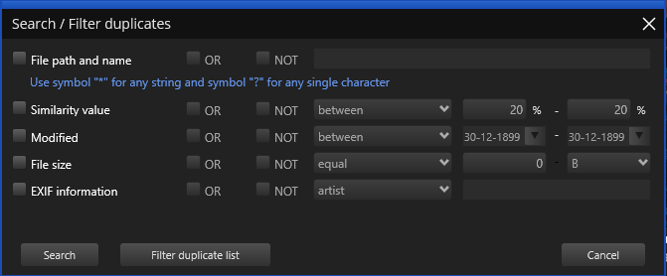

Figure 68: Search / Filter window

The file name field allows you to use wildcard characters where an asterisk (*) represents one or more characters and the question mark (?) represents a single character.

The asterisk in a wildcard matches any character that appears zero or more times. For example, "comp*" matches anything beginning with "comp" which means "comp," "complete," and "computer" are all matched.

The question mark stands for a single character mentioned only once. For example, "c?mp" could be either "camp" or "comp".

You can use this feature and wildcard characters to search DPC scan results quickly and effectively to find the images you need.

How do I save a scan and import it later?

There are two ways for you to save scan results to a file for later use.

**Option 1:**

1. Run a scan and wait for Duplicate Photo CleanerTM to show the scan summary page as depicted in the figure below –

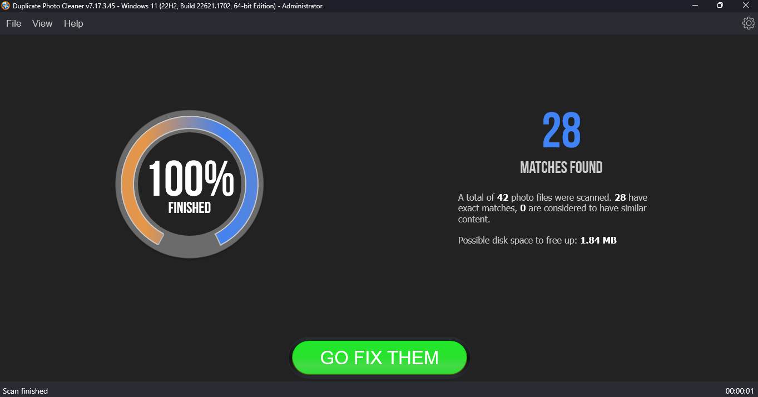

Figure 69: Scan Summary window

1. Click on the GO FIX THEM button. The results screen is displayed as depicted in the figure below –

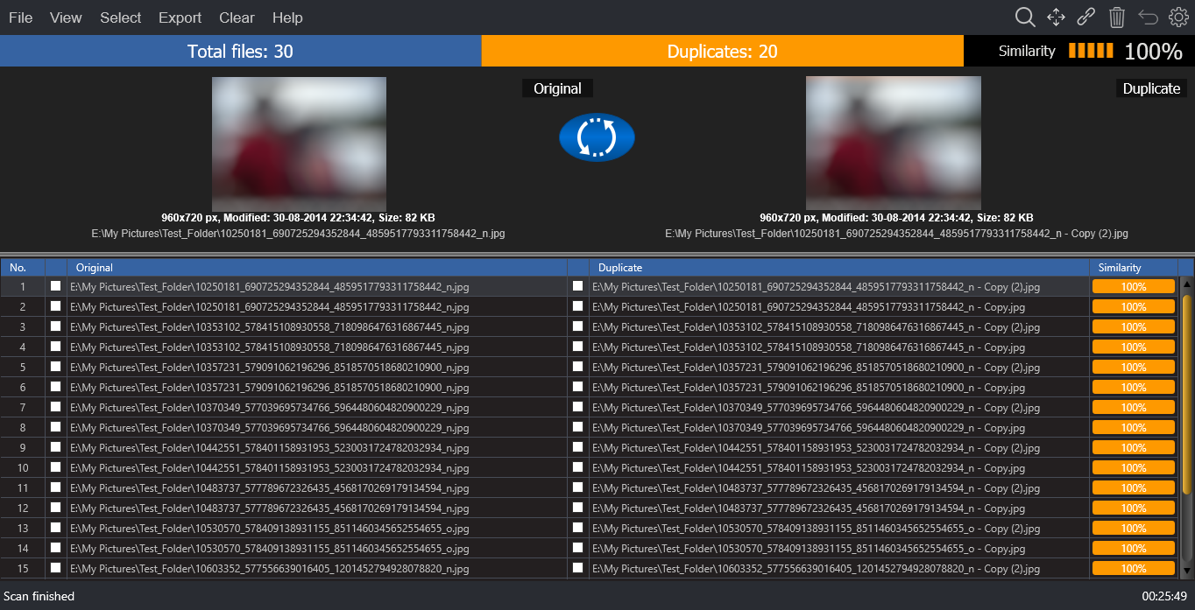

Figure 70: Scan Results window

1. From the main toolbar click on Export > Save Scan option. The Save dialog box is displayed which you can utilize to navigate to a folder location of your choice. Then you can specify a name for the scan data file and click Save. This is how you can save your to your computer.

**Option 2:**

1. Run a scan with Duplicate Photo CleanerTM
2. When the scan is finished, click on the GO FIX THEM button
3. Right-click on the results, select Save duplicate list to file and save the file to your computer

Now you can load the results directly from the list – that will save you a lot of time, especially if you save a scan of a large photo collection.

To import an exported scan, open Duplicate Photo CleanerTM, click on the green plus button, select Import Scan and browse to the list file saved on your computer.

Can I use Duplicate Photo CleanerTM to delete duplicate photos from my smartphone?

Yes, you can! Simply connect your phone to your Windows PC and open Duplicate Photo CleanerTM. It will automatically detect a connected phone and offer to scan it for duplicate and similar photos. Alternatively, open DPC, select Media Device Scan from the scan modes drop-down menu and connect your phone. Your phone may ask you to give Duplicate Photo CleanerTM the necessary permissions (check your phone for notifications). When done, follow DPC's prompts to scan your phone.

Does Duplicate Photo CleanerTM support Android and iOS devices?

You can use DPC to scan your iOS and Android devices for duplicate and similar photos by connecting your phone to your Windows PC and using DPC's Media Device Scan mode.

Do I have to add all the folders with photos when using the Media Device Scan mode?

No, you don't need to add folders one by one. Duplicate Photo CleanerTM uses the Media Transfer Protocol to scan photos on your smartphone, which means that all you need to do is connect your phone and DPC will detect and scan all the photos on the device.

How does Duplicate Photo CleanerTM determine which image is the original and which is the duplicate?

DPC sees an image as the original based on a set of conditions. Here they are in order of priority:

* the file has the largest resolution in the group
* the file has the largest size in the group
* the file is the "newest" in the group (determined by modification date)

My scan got stuck! What to do?

If your scan with Duplicate Photo CleanerTM got stuck or is very slow, don't panic because most likely it's not a bug. This could be happening because you've chosen a very accurate scan mode and added too many images for Duplicate Photo CleanerTM to compare. Just stop your current scan and try the following:

* Add smaller folders - don't scan your entire image library in one go
* If you are using Sector Detail Scan, lower the similarity threshold to 50% and never add large folders
* Eliminate true duplicates first - select Standard Scan and set the similarity threshold to 100%, delete the duplicates and then start looking for similar images in smaller chunks

This will help you speed up Duplicate Photo CleanerTM scans and manage your photos more effectively.

My Windows computer won't let me install Duplicate Photo CleanerTM. What to do?

Most likely, your computer needs you to run the installer as Administrator. Here is how you can do that:

1. Right-click on the duplicatephotocleanersetup.exe setup file
2. Select "Run as Administrator..."
3. Follow the setup instructions

I accidentally closed Duplicate Photo CleanerTM. Is there a way for me to load previous scan results?

Duplicate Photo CleanerTM doesn't save your scan progress automatically but it offers you an option to pause and resume scans. If you've paused a scan, DPC will resume it right where it left off even if you've closed the application.

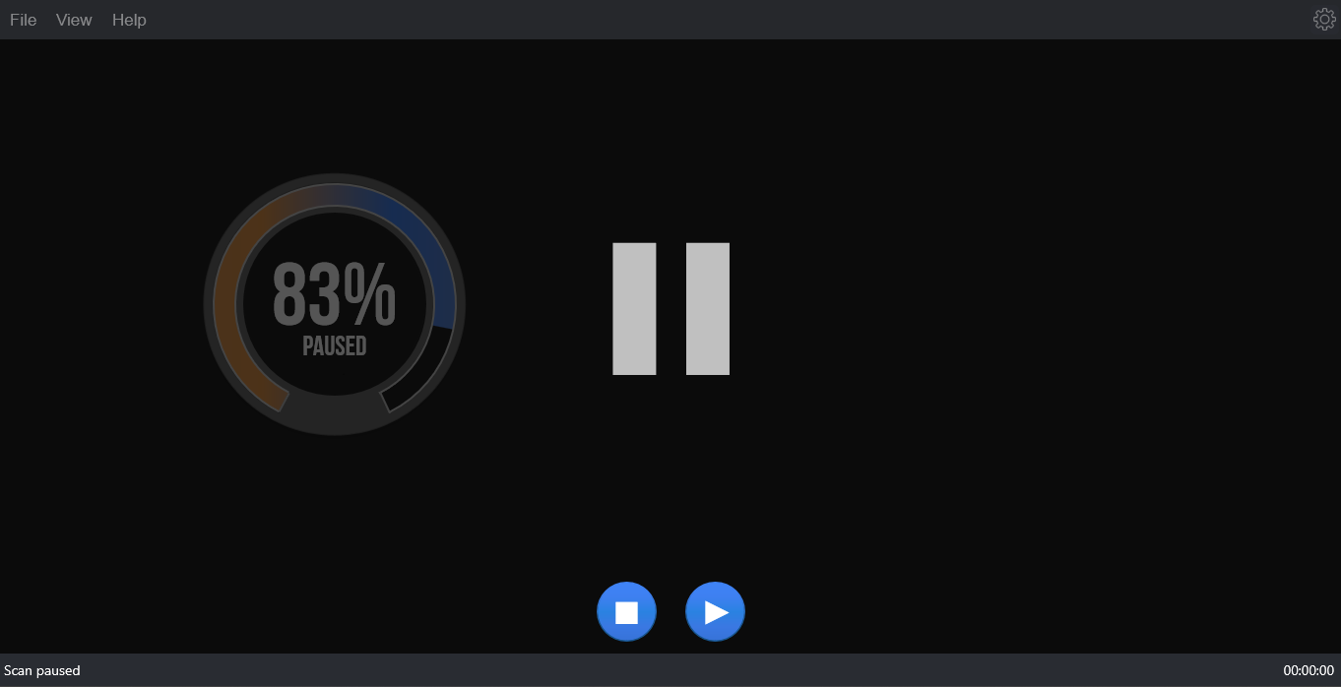

Figure 71: Pausing a scan

We recommend that you use the Pause feature if you decide to abort a scan because you don't have the time to sort through the results. This will speed things up a great deal.

My system crashed and Duplicate Photo CleanerTM got unregistered. How do I get my software up and running again?

First of all, go to www.duplicatephotocleaner.com, download the .exe (Windows) or .dmg (Mac) installation file and install Duplicate Photo CleanerTM. If you have a license key, you can log into your account with the email address used when you purchased your license key from [this](https://www.duplicatephotocleaner.com/login) page. There you will see your current license key. You can also find your license key in the email we sent you when you purchased Duplicate Photo CleanerTM. Use the key to activate Duplicate Photo CleanerTM by running the program and entering the license key in the activation box.

If you discover that your license key has expired, make sure you go to the "[Version History](https://www.duplicatephotocleaner.com/history)" page and install an older version, the one for which you bought the key. Duplicate Photo CleanerTM will work as it should, although you won't be able to download updates. Your key should activate any version released prior to your software expiring.

If you lost your license key, please submit a [support ticket](https://www.duplicatephotocleaner.com/ticket) and send us all the relevant information about your purchase.

I have a drive that has only photos on it. After about 15 minutes of scanning, the program hangs.

Duplicate Photo CleanerTM supports large amounts of files and works on large drives. Please make sure your drive is not damaged and doesn't have bad sectors. Also please make sure you have the latest version of Duplicate Photo CleanerTM installed. You can check for new versions by opening the program, clicking on Help in the menu and clicking on Update.

Duplicate Photo CleanerTM reported that some duplicate files could not be deleted. Why is that and how can I fix this?

There could be several reasons why Duplicate Photo CleanerTM is not deleting these files. Here are the most common fixes for this problem:

1. Make sure you are using Duplicate Photo CleanerTM as administrator. To do that, close the program, right-click on its shortcut on your desktop and select "Run as administrator" from the right-click menu.
2. The files you are trying to delete are being used by another application. Close all programs except Duplicate Photo CleanerTM and try deleting the duplicates again.
3. UAC (User Access Control) is preventing you from deleting the files. Try disabling UAC or editing its sensitivity from the Control Panel, then try deleting the files again.
4. Make sure the files you're trying to delete aren't located on a read-only drive, like a CD or a DVD.

I've installed Duplicate Photo CleanerTM on my Mac but I can't open it. What to do?

Most likely, that's happening because your Mac settings are preventing apps from third party developers from running on your computer. Changing the settings will help. To do that, click on the Apple menu and select System Preferences. When the System Preferences window opens, go to Security & Privacy. On the General tab click on the lock to be able to make the changes and enter your password. Under "Allow apps downloaded from:" select "Mac App Store and identified developers" or "Anywhere". Now you should be able to open Duplicate Photo CleanerTM.

I still use Windows XP on my computer. Is Duplicate Photo CleanerTM compatible with it?

Yes, Duplicate Photo CleanerTM is compatible with Windows XP even though it's designed to work on the newest operating systems to ensure highly accurate results and great performance. However, Windows XP is an outdated OS and even Microsoft stopped supporting it. That's why some users may experience problems using the latest versions of Duplicate Photo CleanerTM on XP. If that's the case with you, we suggest you download the following version:

[Download Easy Duplicate Finder v. 2.4.0.142](https://www.duplicatephotocleaner.com/files/2.4.0.142/dpcSetup.exe)

I use Windows tags to organize my photos and I want to delete images that don't have them. Can DPC help?

Absolutely! Duplicate Photo CleanerTM supports Windows tags. Simply scan your image library and wait for the results to be displayed. You can hover over image thumbnails in Multiviewer to view EXIF data and Windows tags. When you are ready to select the images based on Windows tags, use the "Select files with tags" and "Select files without tags" bulk selection options.

Can I launch Duplicate Photo CleanerTM to scan a specific folder when I'm browsing my computer?

Yes. Duplicate Photo CleanerTM supports Windows context menu, so all you need to do is right-click on a folder you want to scan and select Duplicate Photo CleanerTM.

After the search is complete, I click "Select files with the original names" and no files are selected in some duplicate groups. Why is that?

This means that DPC couldn't identify the original for these groups. When DPC cannot determine the original file in the group because all files match the same criteria (i.e. have the same file name), it will not select any files in the group. You can still use bulk selection options that use different criteria.

When I click "Reverse selection", both files in groups where the bulk selections didn't work become selected.

That's because the "Reverse selection" option changes the selection to the opposite state (selected -> non-selected, non-selected -> selected)

The next section of this user manual includes an **Index** of frequently referred terms or phrases with reference to the Duplicate Photo CleanerTM application and its usage.

Index

A

Abbreviations / Acronyms used in this User Manual v

About this User Manual iii

Activating your DPC Installation 28

D

Downloading the DPC Application Installer 10

F

Frequently Asked Questions (FAQs) 65

G

Getting Started 11

I

In Scope of this User Manual iii

Intended Audience of this User Manual iii

Introduction 10

L

Limitations of Utilizing an Unregistered DPC Application in Trial Mode 21

O

Organization of this User Manual iii

Out of Scope of this User Manual iii

P

Performing a Folder Comparison 44

Performing a Fragment Search 61

Performing a Lightroom Classic Scan 52

Performing a Mobile SmartScan 38

Performing a PaintShop Pro Scan 56

Performing a Picassa Scan 48

Performing a Standard Scan 34

Purpose of this User Manual iii

R

Registering your DPC Application Installation 22

Removing your DPC License Details 31

T

Terms Used in this User Manual v

The General tab 13

The Ignore List tab 18

The Logging tab 17

The Scan Settings tab 15

The Settings Panel Detailed Description 13

The Sounds tab 19

The Support tab 20

Typographical Conventions / Customaries used in this User Manual iv

V

Via the DPC Homepage 22

Via the Register Button of DPC Application 25

W

Why do I need Duplicate Photo Cleaner™? 65